INTERNATIONAL DAY OF ZERO TOLERANCE FOR FGM
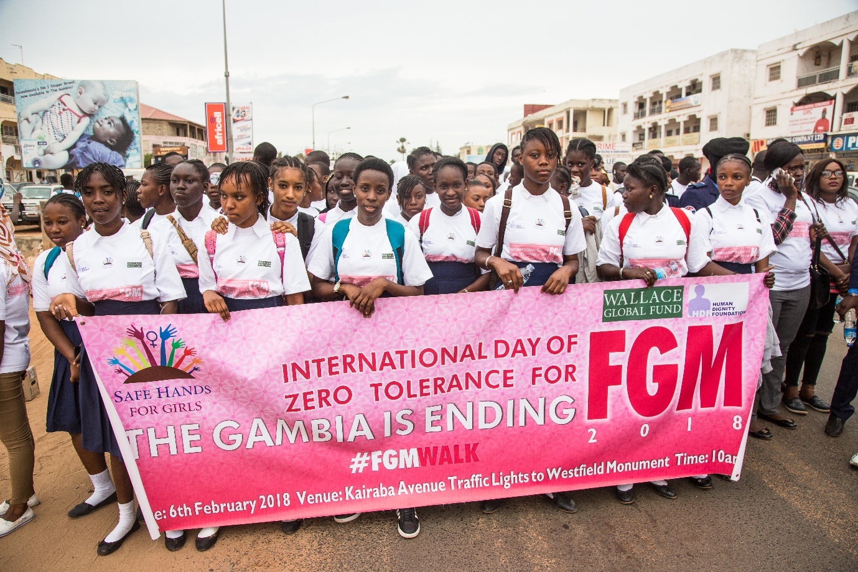

Organized by Safe Hands for Girls
Venue: March pass from Traffic Lights to Westfield
06th February 2018

Contents
Acknowledgement
Executive Summary
Introduction and Background
Highlights of the Report

Acknowledgement:

Safe Hands for Girls would like to acknowledge the partnership, collaboration and support of the following institutions:

- Wallace Global Fund and Human Dignity Foundation for the financial and moral support towards the successful implementation of this activity.
- To our regional representatives for mobilizing the participants from the regions for this activity.
- To the ministry of basic and secondary education through the regional education directorate for mobilizing students to participate in this activity
- Special thanks to the Safe Hands for Girls team and all the individuals that contributed to the success of this activity.

Executive Summary
Safe Hands for Girls is a survivor led women’s right organization that aims at eradicating Female Genital Mutilation and all other forms of Gender Based Violence through awareness raising, advocacy, youth empowerment and community outreach.

Our mission is to create awareness on the harmful effects of Female Genital Mutilation, help fight to eliminate it, and provide support to survivors of the practice. Safe Hands for Girls initiates change at both the community and institutional levels to bring about positive and enduring transformation.

Introduction and Background
In the Gambia, Female Genital Mutilation/Cutting (FGM/C) is one of the most common forms of Gender Based Violence (GBV) practiced at a prevalence rate of 75% among women aged 15 - 49 (DHS, 2013). Also, there is widespread acceptance of its continuity by communities. According to UNICEF MCIS IV, 2010 64.2% of the population supports the practice.

A frequently asked question in the international discourse on FGM/C is ‘why do people do it?’ One wonders how loving parents can allow their daughters to be subjected to FGM/C despite knowing the pain and health consequences involved. The answer to this question can mainly be found in the socio-cultural dynamics and misconceptions surrounding the practice. In the Gambian context, these include stigmatization, discrimination, social exclusion, calling name ‘Solima’ and labelling of women and girls who are not cut. In addition, there is a strong belief by many practicing communities that FGM/C is a religious obligation and ‘honour for women’, therefore, women who are not cut wouldn’t be given due respect in those communities. Despite, it is also belief that women wants to maintain the practice for marriage purpose hence it is belief that it reduces women’s desire for sex and therefore, make girls to maintain their virginity and women to be faithful to their husbands. In that respect, it encourages men in practicing cultures to marry girls and women who are cut.

International legal instruments identified FGM/C as a harmful traditional practice and a human rights violation. The Convention on the Elimination of All Forms of Discrimination against Women (CEDAW) and the Convention on the Rights of the Child (CRC) call on states to employ strategies to eliminate harmful traditional practices. In Africa, the AU Protocol to the Charter on Human and People’s Rights on the Rights of Women explicitly calls on states to prohibit and condemn FGM/C through the adoption and enactment of laws aimed at eliminating it. The Gambia has ratified and domesticated these international legal instruments into national laws through the enactment of the Children’s Act 2005 and the Women’s Amendment Act 2015 following the presidential pronouncement to band FGM/C in November 2015. The Children’s Act 2005 prohibit harmful traditional practices against children which include FGM/C and the Women’s Amendment Act 2015 prohibit female circumcision (FGM/C) to protect children and women from the practice as well as to protect their sexual and reproductive health and rights.

It is against this background, Safe Hands for Girls organized a march pass in commemoration of the 15th year of the international day of Zero Tolerance for Female Genital Mutilation, initiated in 2003 by the United Nations as part of UN’s efforts to eradicate Female Genital Mutilation. On the 6th of February, every year, is a time to galvanize actions and accelerate the abandonment of Female Genital Mutilation around the world. This year marks two years since the practice was criminalize in the Gambia which gave Safe Hands an opportunity to reflect on the challenges and the opportunities present to have a country free from FGM and other harmful traditional practices confronting girls and young women.
It is the very first time that a march pass with such an organic crowd took place. What is even more fascinating about this activity is the involvement of young people to speak against female genital mutilation. The involvement of young people in combating women’s marginalization and violence is a strategic approach many countries around the world are using. For Gambia, it is not just about having young people to declare their support for girl’s education or women’s wellbeing, Safe Hands for Girls with its partners are working with young people to break barriers and challenge harmful traditions that have rendered women voiceless and vulnerable to violence in the homes, schools, and work places. The symbol behind this activity is simple: young men and women questioning aged –long practices that have justified violence against girls and women. There cannot be a more courageous approach than this.

Proceedings:
In Safe Hands drive to bring about greater respect for the rights of women and girls and zero-tolerance for Female Genital Mutilation, Safe Hands for Girls joined the rest of the World to commemorate International day of Zero Tolerance for Female Genital Mutilation with the local theme: The Gambia is ending FGM in the form of a one day caravan and launch of the “Pink Bus Tour”.
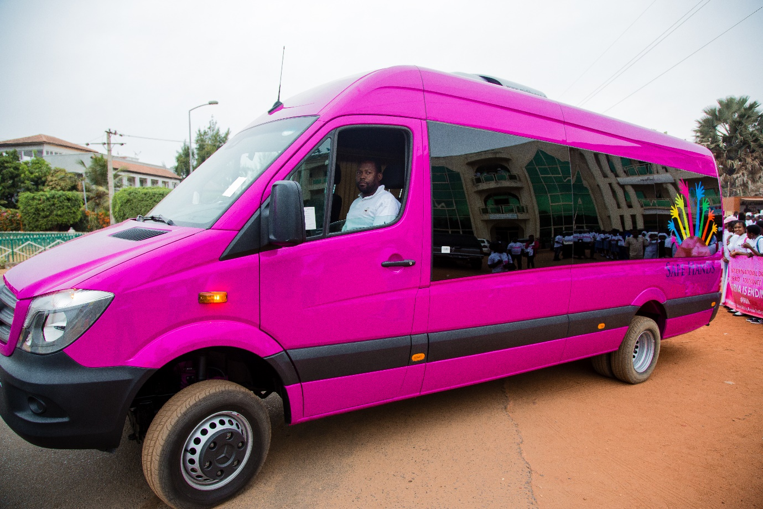

The activity started with a convergence at traffic lights and constituted a procession from traffic lights to Westfield Monument. The procession was in striking style with a combination of young people and their groups, women’s rights activists, political leaders, the media, and members of the civil society and academia. Which was by accompanied by a PA system. Messages about FGM on T-Shirts, posters, flyers, stickers and banners were also displayed.

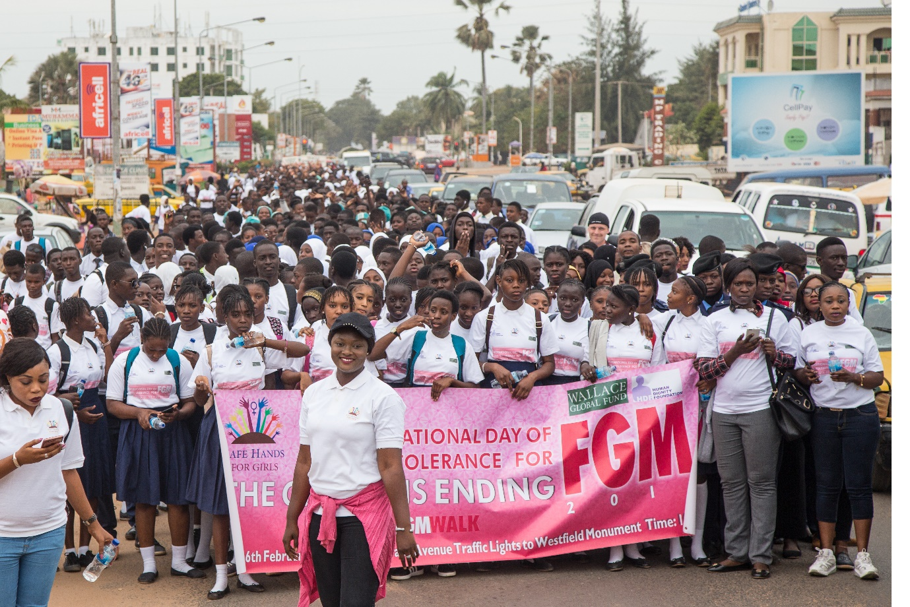

The activity was led by Jaha Dukureh-founder of safe hands for girls who used the opportunity to informing the crowd about the importance of commemorating the International day of zero tolerance for FGM. Jaha called on the government of the Gambia to bridge the gaps in the women’s amendment act and bring people who subject women and girls to FGM to book. Jaha also urged women and girls to discuss the effects of FGM in their gatherings and circles and called on the international community through the Gambia government to increase funding that goes to FGM work.
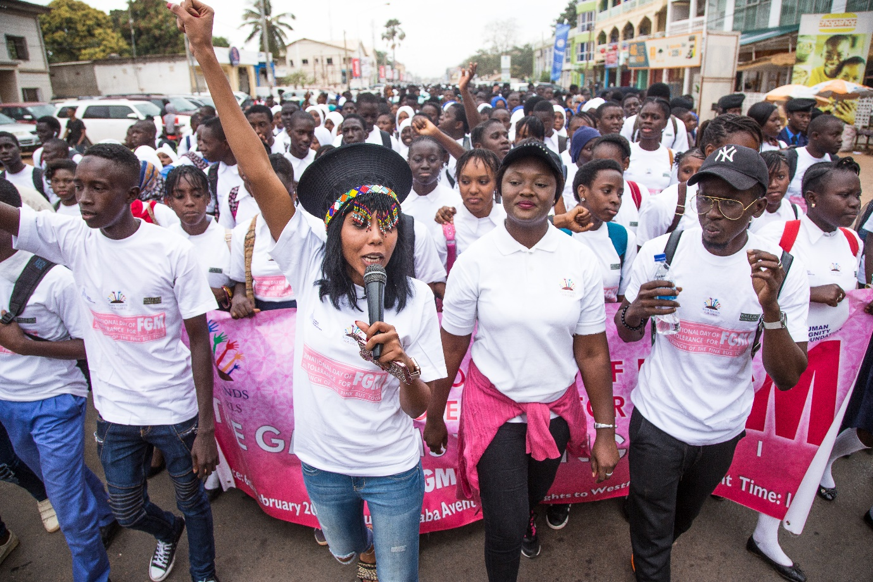
After Jaha, was Barhama Cham- A renowned musician in the Gambia who also spoke about the importance of women empowerment and called on his fellow young people especially men to address the issue of Female Genital Mutilation. He said for decades, the women’s movement has led the struggle for gender equality. Although important advances have been made in the rights and well-being of women and girls with regard to health and education, and to a lesser extent in political and economic participation, substantive gender equality is yet to be achieved anywhere in the world. Progress has stalled and we are a long way away from realizing the full promise of gender equality, women’s human rights and women’s empowerment. This moment in history represents a unique opportunity to position gender equality and women’s empowerment at the heart of the global agenda.

Barhama said that men and boys have a greater role and accountability in the achievement of gender equality, and argued that the achievement of gender equality has two pre-requisites. The first is cultural and social change – or, men’s and boys’ acceptance of the importance and benefit of a gender-equal society, which is more likely to occur when men can see positive benefits for themselves and the people in their lives’. The second is institutional change. Despite this recognition, the enlisting of men and boys as equal partners in the crafting and implementing of a shared vision of gender equality is yet to be fully realized.
After the speakers, the students and young people sang and chanted messages on gender equality with focus on FGM and urged their parents and the government to put a stop to this menace.
From the march pass the students gathered at the Westfield monument, were they had a talk with Imam Baba Leigh, a renowned imam and Islamic scholar, who talked to the young people about the effects of FGM and said in no uncertain terms that FGM is not a religious obligation. Baba Leigh in his speech said the FGM is a deep-rooted cultural practice that predates Islam and was never taught by the prophet nor his disciples. He urged his fellow religious leaders to propagate the teachings of Islam and demystify the myths about FGM.
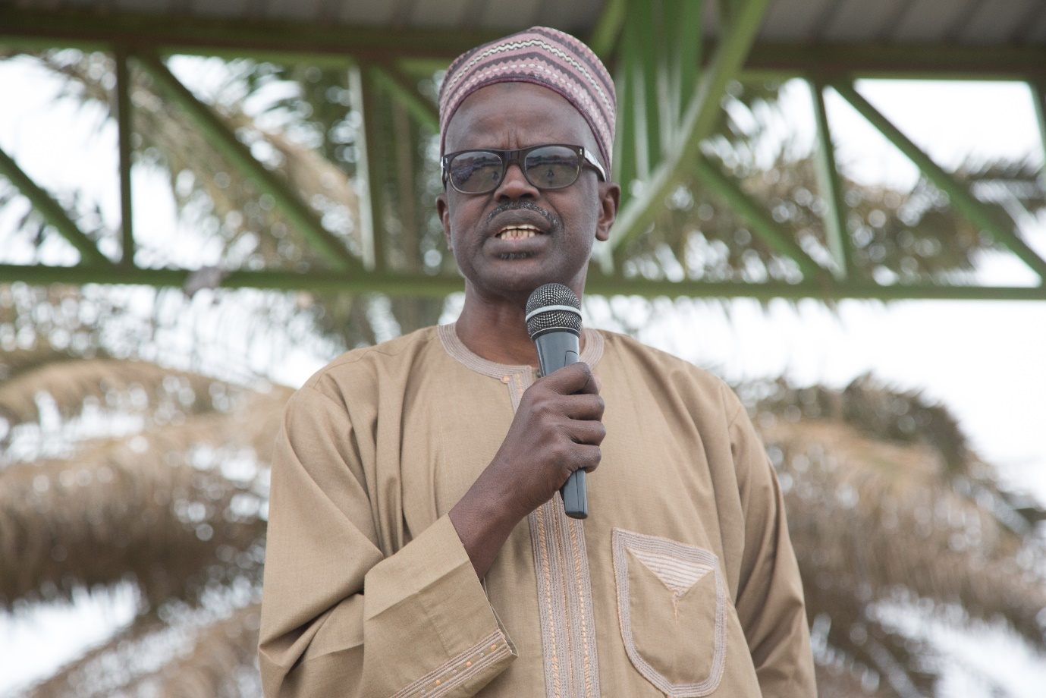
This was followed by a question and answer session between the students and young people with the imam.
After this was followed by the launching of the pink bus tour which was done by Jaha Dukureh Founder-Safe Hands for Girls.

Challenges/Observations
- Getting students to leave their schools to participate in the activity was a challenge
- Getting the vice president of the Gambia was a challenge as he was supposed to attend another activity that very day

