School Outreach: Peer Group Advocacy Training on FGM for Students
THEME: Promoting Youth Participation in the Campaign to End FGM
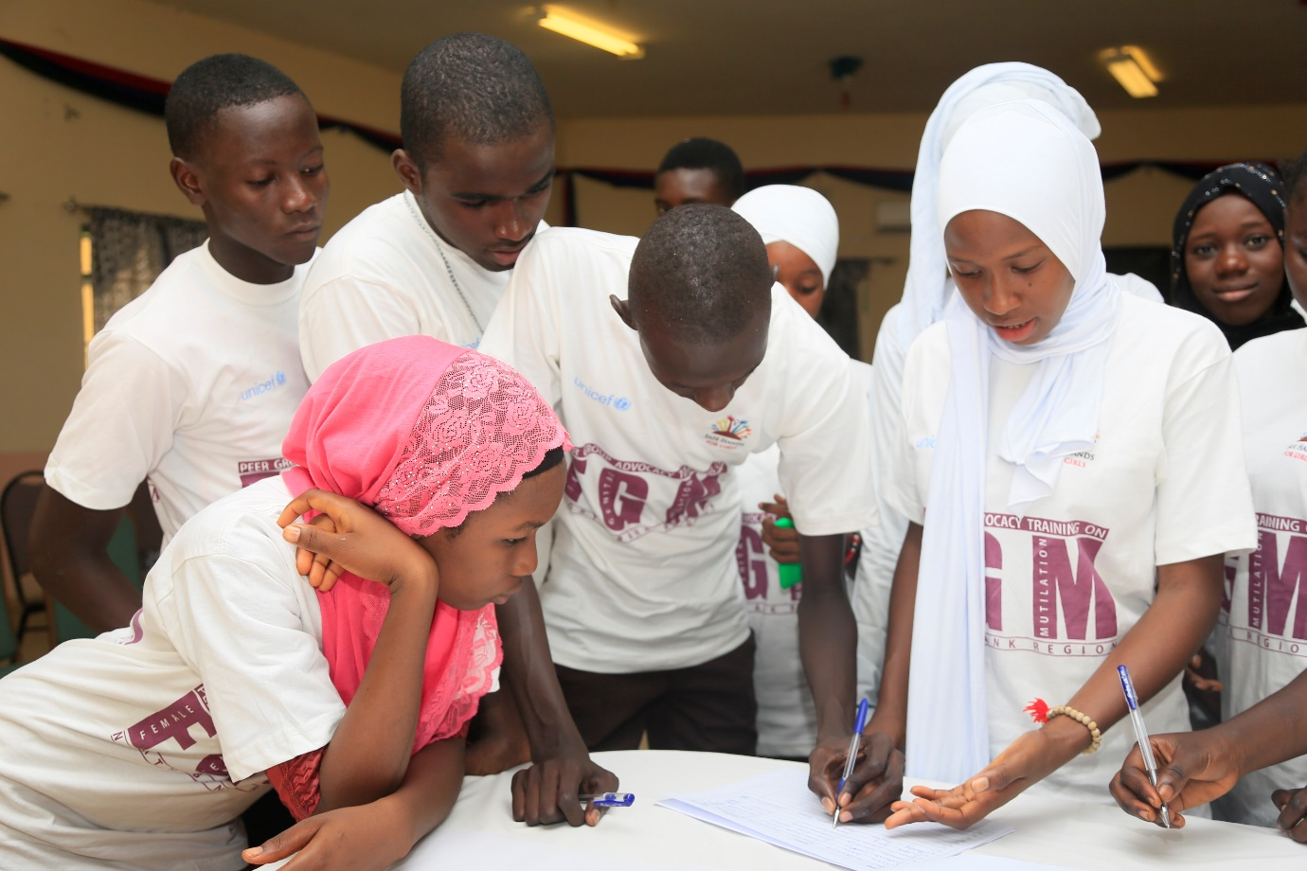
Organized by Safe Hands for Girls
Funded by UNICEF - The Gambia 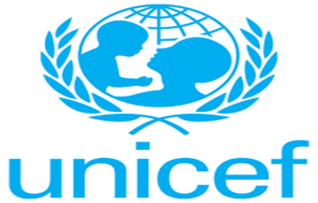
North Bank Region, The Gambia.
Dated: October 26th - October 29th 2017
Contents
Acknowledgement
Executive Summary
Introduction and Background
Preface
Highlights of the Report

ACKNOWLEDGEMENT
This training is to raise awareness on Female Genital Mutilation and its harmful effects.
We cannot do much without expressing our sincere gratitude to UNICEF for funding the project.
Special thanks to the Safe Hands for Girls team and the individuals who had the courage to step up and volunteer.
Appreciation is extended to Oustass Jassey for his contribution to the success of the training.
I wish to thank to all the students, teachers and principals for their participation.
We also thank Fatoumata J. Newlands for preparing the report.

EXECUTIVE SUMMARY
The United Nations Children’s Fund (UNICEF) is a United Nations programme that is part of the UN body which provides humanitarian and developmental assistance to children in developing countries. UNICEF protects and defends the rights of children across 190 countries worldwide.
Safe Hands for Girls is a survivor’s led organization that was founded in 2013 to help eradicate the practice of Female Genital Mutilation and all other forms of Gender Based Violence through advocacy programs, as well as to provide support to women and girls who are survivors.

INTRODUCTION & BACKGROUND
Female Genital Mutilation (FGM) is a deeply rooted tradition practiced in The Gambia by different ethnic groups throughout the country in all regions. Despite this harmful practice people believe that FGM is a religious practice. This results up to severe long-term health effects including psychosocial effects that can deeply affect the lives of young women and girls.
As a result, Safe Hands for Girls with support from UNICEF organized the training on FGM and Advocacy as part of the strategic plan. The training is a follow-up program of the school outreach wherein school clubs will be formed which Safe Hands will be working with directly. The training is a way to measure our impact on the school outreach that took place earlier this year in North Bank. The peer group training is basically to target students of the age group 12- 19 years specifically in order to enable them to develop advocacy skills and enhance their understanding on the effects of FGM that will help them in campaigning against FGM.

OBJECTIVES
- Encourage the students to take part in the anti-FGM campaign.
- To orient the students on the effects of FGM.
- To train the students on the law against FGM.
EXPECTED OUTCOMES
- Get students to disseminate the information they gained during the course of the training with their peers.
- To enhance the students’ overall understanding on the effects of FGM.
- To enable the students to understand the laws governing FGM.

PREFACE
This report highlights the presentations, requests, challenges and lessons learnt during the training.
Sixty (60) participants were trained on FGM and Advocacy whereby they were trained in different sets due to the number of trainees.
HIGHLIGHTS OF REPORT
Opening Ceremony
The opening ceremony was chaired by Sait Matty Jaw, the National Coordinator of Safe Hands for Girls. After the usual opening prayer, he gave a welcoming remark.
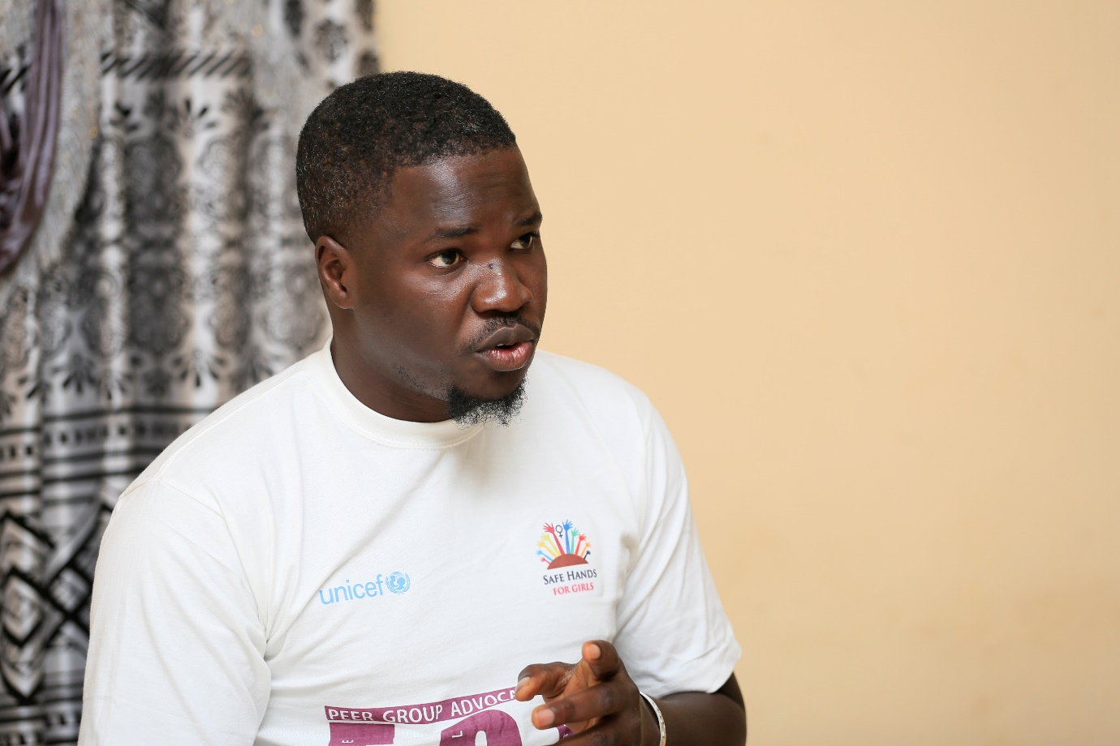
A statement was given by the PRO of the Farafenni General Hospital (SHfG Regional Representative), Mr. Sainey Dibba wherein he encouraged the students to participate fully in their capacities to make the training a successful one.
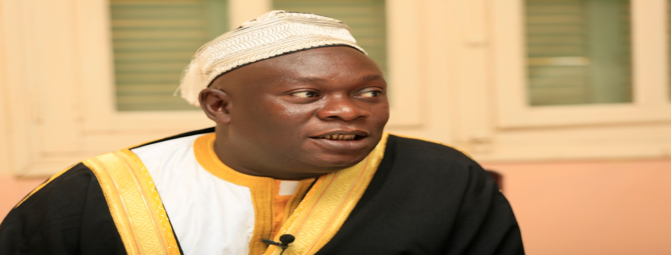
Jaha Dukureh, the founder of Safe Hands for Girls was called upon by the chairperson to give a statement. She spoke on her story and what encouraged her to start campaigning against FGM. She urged the students to do the same cause they are the key to bringing an end to FGM.
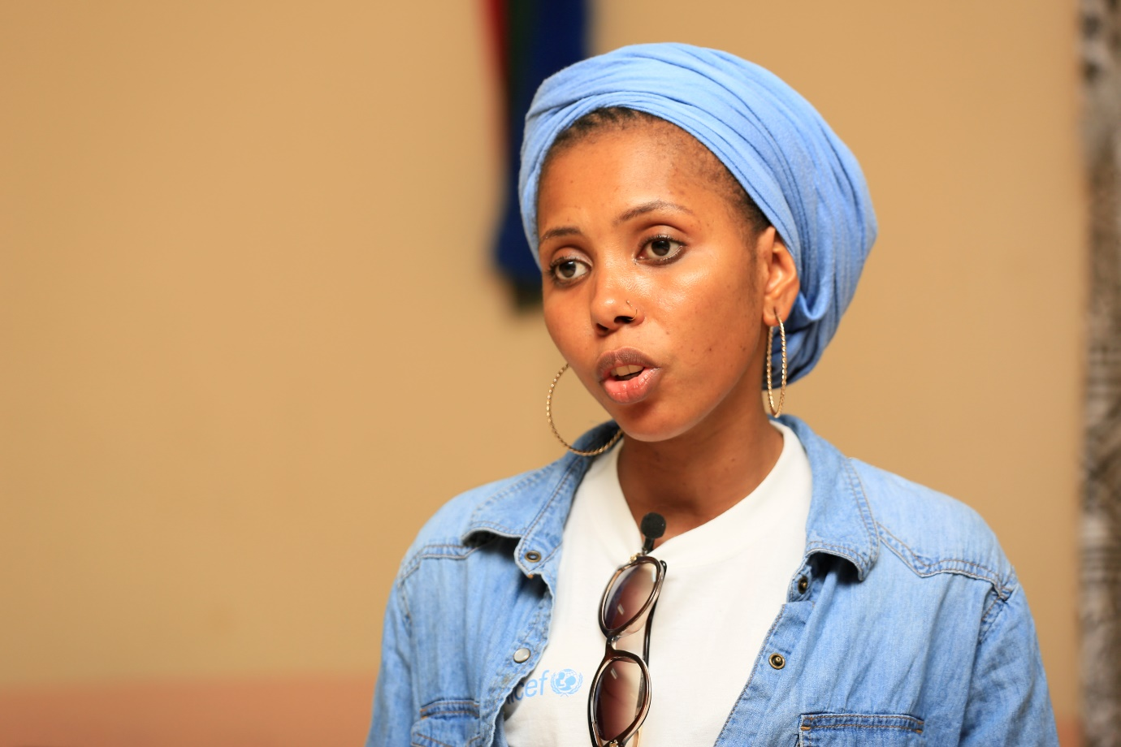
The chairperson called on the participants to introduce themselves wherein they did. The team introduced themselves and mentioned their respective position as well. He then handed over the floor to Mam Lisa Camara (Programs Manager).
Mam Lisa gave a brief history of Safe Hands for Girls on which she stressed on the aims of the organizations. She also emphasized on the purpose of the training and coaxed the students to participate immensely.
A group photo was taken and then breakfast was served.

Number of Trainees: 60
Schools:
- Kerewan Basic Cycle
- Kerewan Senior Secondary School
- Kuntaya Senior Secondary School
- Berending Senior Secondary School
- Kuntaya Basic Cycle
- Essau Senior Secondary School
- Farafenni Senior Secondary School
- Njaba Kunda Upper Basic School
- Farafenni Upper Basic School
- Ngayen Sanjal Upper Basic School
- Anglican Mission Upper Basic School
- Albreda: Aji Fatou Bojang Senior Secondary School

Session One: Health Complications of FGM and Early Marriage
This session was facilitated by Fatoumata J. Newlands (Programs Assistant) and Mass Laye (Programs Officer for Training and Outreach).

Health Complications of FGM
Ms Newlands facilitated the first part of the session.
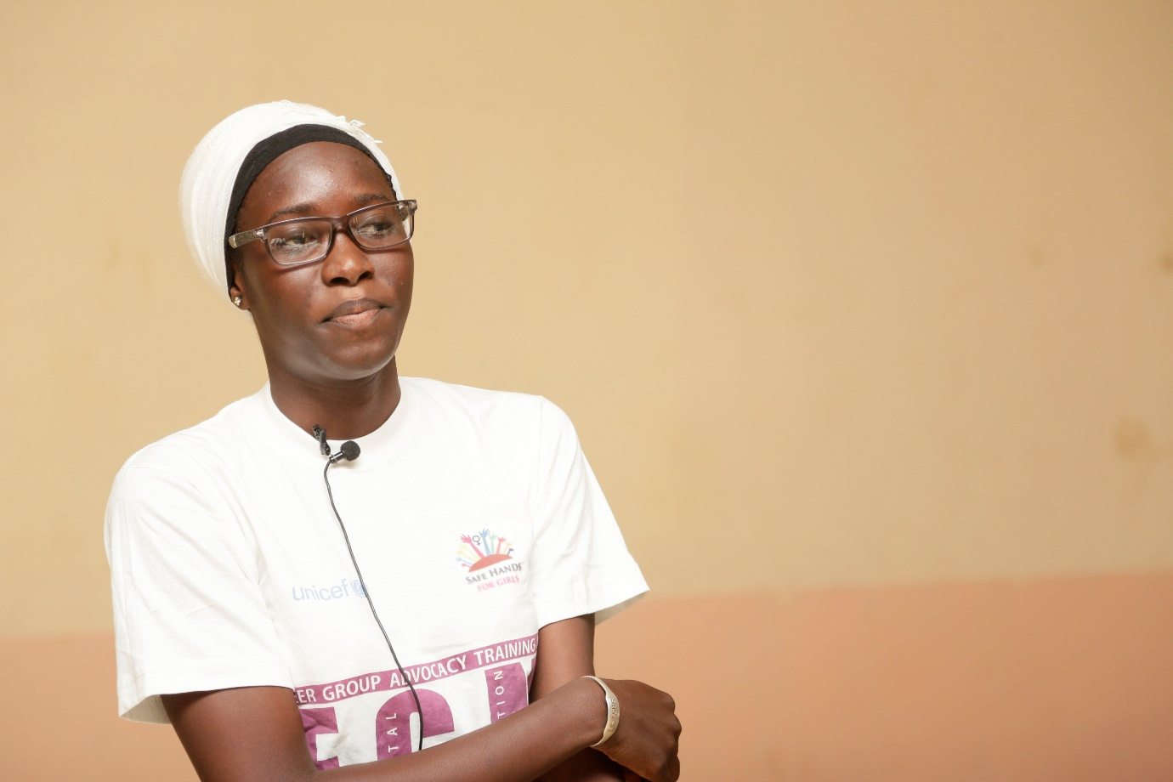

She gave a short introduction of Female Genital Mutilation/Cutting. Ms Newlands also elaborated on tradition and how it influenced the practice of FGM. She first started by defining tradition;
- Tradition is the transmission of customs, beliefs and values from generation to generation often guided by taboos that are not easy to change.
She also gave examples of the different types of traditions some of which are stated below;
- Beneficial Tradition; Breast feeding, special care and nutritious diet for a newly delivered mother
- Harmful Tradition; FGM, food taboos, early marriage, preference of a male child
- Neutral Tradition; Wearing a talisman, wearing charms, wearing charms
Next she defined FGM;
- FGM is the partial or total removal of the external genitalia or other injury to the genitalia for non-medical purposes.
- Other procedures; introduction of corrosive substance or herbs, tightening and narrowing the vagina
She enlightened on the management of wounds some of which are;
- Applying lemon juice, ash or alcohol
- Applying herb mixtures onto the wound
- Applying cow dung
- Applying porridge
Ms. Newlands then handed over to Mr. Laye.
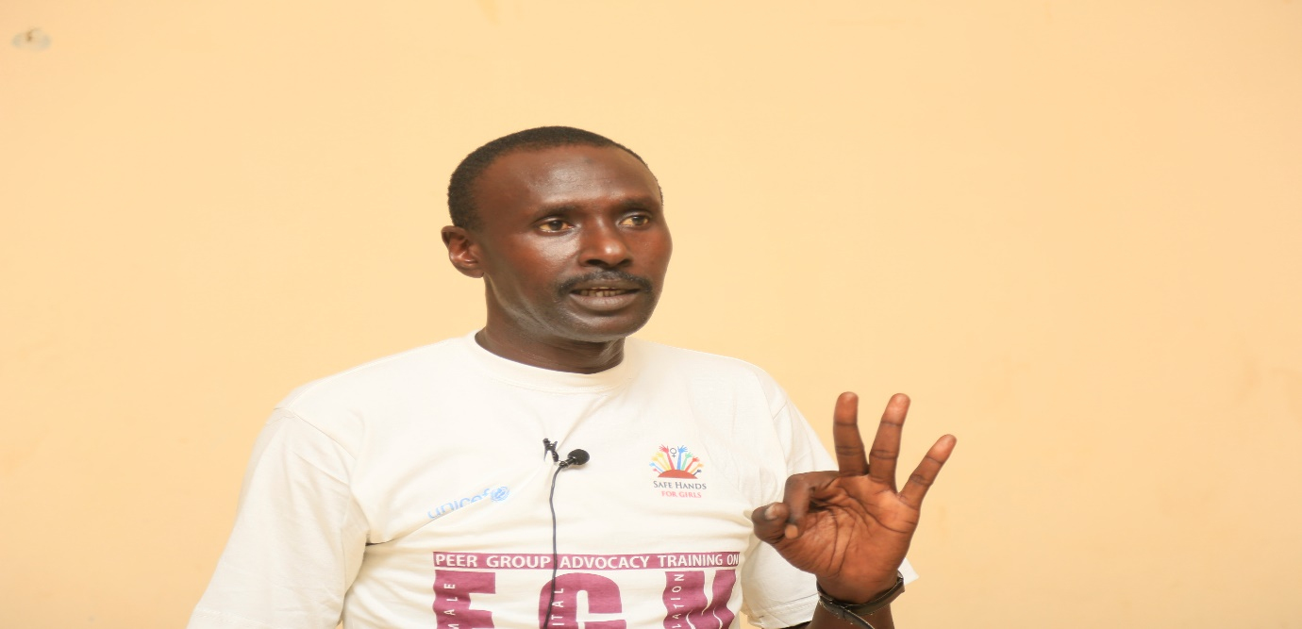
Mass stated the general objectives. He then went further press on the introduction of FGM followed by the definition of FGM.
Next, he elaborated on approaches to changing a harmful tradition;
- Community involvement
- Mobilization of youths
- Raising awareness
- Introduction of anti-FGM laws
- Training of health workers
Mass asked the students what is the reason for practicing FGM to test their understanding.
Answers;
- Protect the girls’ virginity
- Minimize the sexual urge of the girl
- Tradition
- Religious and spiritual
- Helps the woman during delivery
He made it clear that the points mentioned above are all misconceptions.
Showed a picture of a normal female genitalia.
He elaborated on the parts of the genitalia.
- The clitoris is the organ that consists of 8000 nerves which facilitates childbirth and sexual stimulation.
- The labia majora are responsible to protect the internal organs and acts like an elastic during delivery.
- The labia minora protects structures and openings and for sexual stimulation.
- The vaginal opening serves as the passage for the baby during delivery, for menstrual flow and for sexual intercourse.
- The urethra opening serves as a passage for urine.
He went on further to elaborate on the types of FGM.
- Type 1; It involves the removal of partial or all of the clitoris.
- Type 2; It is the removal of the clitoris together with the labia minoras.
- Type 3; Excision of part or total of the external genitalia and stitching/narrowing of the vaginal opening also known as infibulation
- Type 4; Other procedures, these are the unclassified types for example piercing, stretching of the clitoris or the like.
Some of the instruments used for FGM are; Knives, scissors, razors, piece of glass, sharp stones and cauterization (burning).
He then pressed on the wound management, then the origin of FGM followed by the so-called reasons of FGM.
The prevalence of FGM in The Gambia and globally was also tackled by Mass wherein he stated the practice is an ethnical practice, not all tribes practice FGM.
Mr. Laye started with the origin of FGM then followed by the reasons of performing FGM.
Mass showed pictures of FGM on the screen which helped the student to understand more. The pictures shown were;
- Haemorrhage
- Abbess
- Child being who was being cut struggling
- Herb mixtures with no expiry date
- Tools used for cutting
- Seal vagina
- External female genitalia with keloids
- The process of cutting
- A sealed woman in labour
- Female reproductive system diagram
He then pressed on the wound management, then the origin of FGM followed by the so-called reasons of FGM.
The prevalence of FGM in The Gambia and globally was also tackled by Mass wherein he stated the practice is an ethnical practice, not all tribes practice FGM.
A 10 minutes break was taken to lighten up the session where the students played a game called “jeri ko, jeri salam”.
Mass resumed with the presentation on the health complications of FGM. Some of which are;
- Injury
- Severe pain
- Shock
- Fracture or Dislocation
Mass went on further to elaborate on the ways boys open their sealed girlfriends in order for them to have penetrated sex. The different procedures are mentioned below;
- They use candles wherein they slowly put the candle in the vagina to stretch the vaginal wall for easy penetration.
- Vinegar is sometimes used whereby a cloth is soaked in a container full of vinegar after which they start rubbing the cloth on the seal until it breaks.
- Some boys also use their fingernails to open their girlfriends’ seals.
Nurses are now trained on how to open seals. The child/woman will be admitted in the hospital wherein the nurses will treat the wound until it has healed. They then will supply the victim with a lubrication which they will use for sexual intercourse.

Early Marriage
Mr. Laye questioned the audience.
Question: Who is a child?
Answers;
- Is a person below 18 years.
Then he continued by asking what was the meaning of child marriage.
- Child marriage is when you send a child or a person below 18 years of age into a matrimonial home.
He went next by stating the consequences.
- It can cause fistula.
- Death
- Isolation
- Child birth complications
- Depression
- Stress
He went further to mention that children that are victims of child marriage are prone to cervical cancer because they are engaged in sex early.
The Principal of Kerewan Basic Cycle and Senior Secondary School added that there is a nearby school that is deeply affected by child marriage because the ratio of boys in the school is more. This is because most of the girls are sent out for marriage.

Session Two: FGM and Religion
Oustass Jassey thanked Safe Hands for Girls for giving him the opportunity to attend the training.
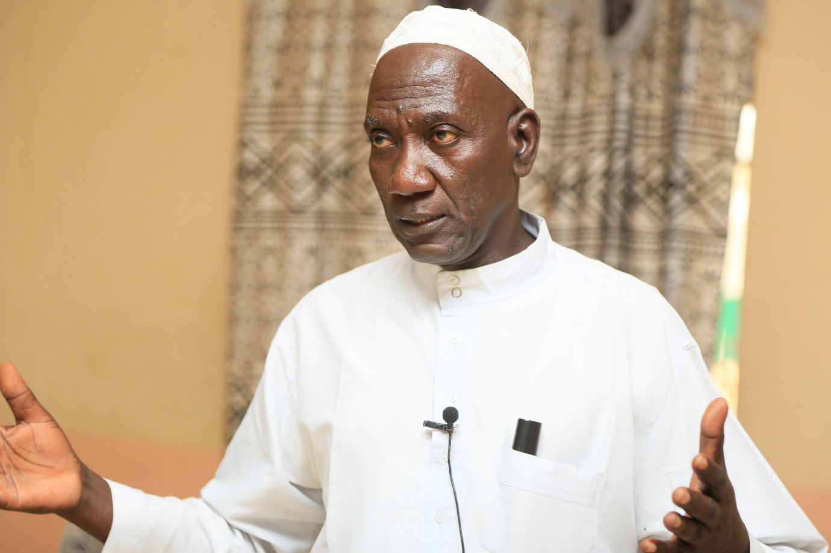
He went on straight to talk on the religious perspective regarding FGM. He gave evidences that FGM is not a religious practice. He emphasized that there was no proof in the Qur’an that the prophet Muhammed S.A.W. recommended that the practice should be performed. The prophet did not circumcise none of his female children and that FGM was performed during the Jahiliyya period. Oustass went further to say that the best way to train a child is by telling didactic stories. He gave the opinion of scholars with regards to FGM and Islam. He made it clear that FGM is deeply-rooted cultural practice and not an Islamic practice. He added that FGM is a practice done out of honour called “Makramah” in Arabic. He concluded by saying that all the so-called reasons are misconceptions.

Recap
Marie Jeng (Programs Assistant) facilitated the recap session. She asked all the participants what they learnt in the training.
Ms Jeng then invited Awa Gai (Administrative Assistant) on the stage to talk on the laws banning FGM.

Session Three: Law Banning FGM
Awa Gai in her capacity introduced herself and asked the students what they understand by the “Law Banning FGM” and if they have an idea about the provisions of the law with regards to FGM.
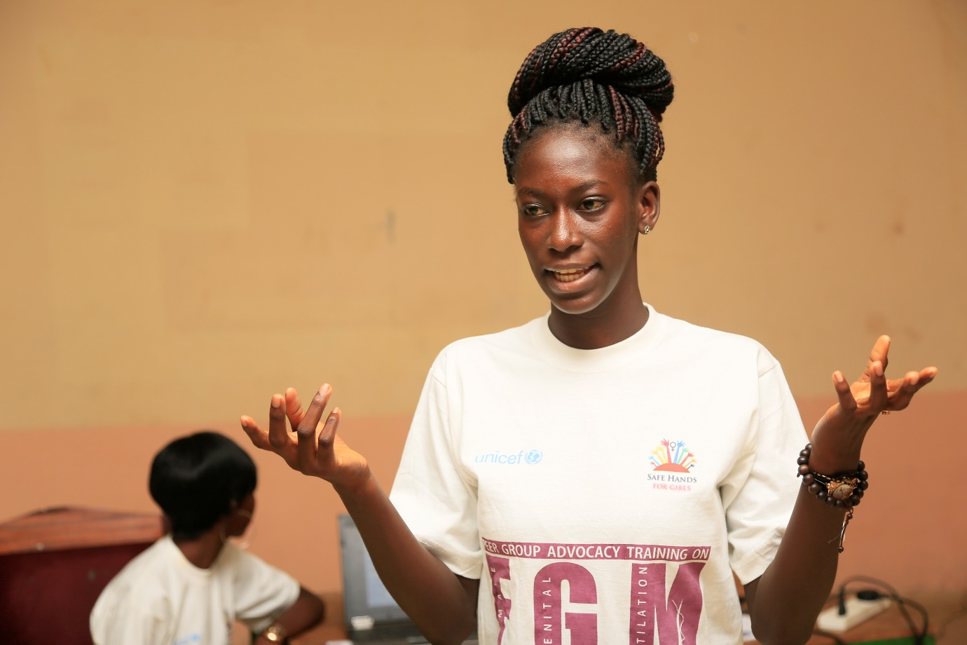
Answers;
- It is a law preventing harm from FGM/C.
- To ensure that people don’t practice FGM.
- To punish those that practice FGM.
Ms Gai defined the law banning FGM;
- As a mechanism put in place to deter people from the harmful practice of FGM and to punish those that go against such law.
- In other words it is referred to as the Anti-FGM law.
Alpha Barry, one of the trainees mentioned some of the provisions stated in Anti-FGM law.
As provided in the Women’s Amendment Act 2015, Ms Gai stated:
Section 32A (1)
- Provides that the person who engages in FGM (circumciser) is liable upon conviction to pay a fine of D50, 000 or 3 years imprisonment or both.
Section 32(B) provides that;
- 1) Accomplices to the practice of FGM are liable upon conviction to pay a fine of D50, 000 or 3 years imprisonment or both.
- Failure to report; when you know that the practice is happening or about to happen.
Punishment: Will amount to a fine of D10, 000
In addition, Section 32A (2) states that where FGM causes death, punishment will be life imprisonment. Reference was made in the case of the Sankandi v IGP.
Ms Gai made it clear that, in as much as Jammeh made the public pronouncement in 2015 to ban FGM, after which it was included in the Women’s Amendment Act, does not make it a Jammeh law. Therefore the law is here to stay.
Marie added that when the Act was made, Section 32A was not part of it, that it was later included.
Ms Gai told the participants that FGM is a violent act and that there are other laws that state it indirectly as a form of inhumane treatment and a violation to the rights of women and girls. She added that if they wanted to get more information they can refer to the regional and international instruments as stated below;
- The 1997 constitution of The Gambia Section 21 and 28, states that women should be free from all forms of violence and inhumane treatment.
- Children’s Amendment Act 2016 Sections 19 and 24 emphasizes on the protection of the child from harmful social customary practices and criminalizes child marriage respectively.
- CEDAW-Convention on the Elimination of all forms of Discrimination Against Women
- ACRWC Article 21 (1A) states the same.
- CRC-Convention on the Rights of the Child
Isatou G. Sayang, a student from Kerewan Basic Cycle performed a short drama. After the drama, Tida Njie (Finance Manager) asked the students what message the drama conveyed. The answers are stated below;
- You should not be discriminated.
- Protect yourself.
- You should move with good friends rather than bad ones.
- Education is very important.
Ms Jeng facilitated the second set. She started by conducting a test of practical for the students, such was done to test your understanding on the subject matter. She went to share the outline of the presentation with the trainees. Next, she went on to state the laws governing FGM and their punishments.
Marie added that there were international and regional instruments that are against FGM and that they can refer to them for any clarification on the law.
She concluded with the Sankandi v IGP case.

Session Four; GROUP WORK
TOPIC; Importance of Youth Involvement in the Fight to END FGM and Child Marriage
The group work was done to measure the students’ understanding on the effects of FGM and Child Marriage.
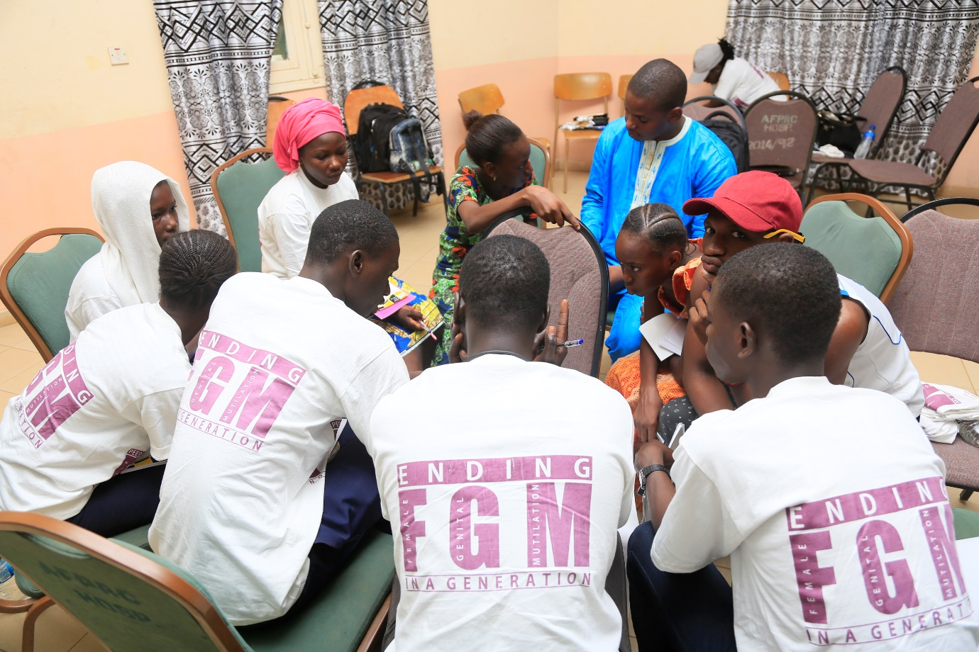
Kuntaya Basic Cycle and Kuntaya Senior Secondary School
Presenter; Bubacarr Sissaho
- Youth involvement can prevent miscarriages and infant mortality.
- They are agents of communication.
- They serve as advocates.
Berending Senior Secondary School
Presenter; Fatou B. Sonko
- Youths serve as a chain in the fight against ignorance towards FGM.
- Youths serve as agents of advocacy.
- Youths are the fastest agents to spread information.
- Youths are victims of child marriage which facilitates their involvement because he who feels it knows it better.
- They can ensure that such is included in the school curriculum to enlighten the students on the effects.
- They are the best agents to ensure that cases of such nature are reported.
Question; What is maternal mortality?
- Maternal mortality is the rate of death of a pregnant woman or death of a woman within 42 days of termination of pregnancy.
Kerewan Senior Secondary School and Kerewan Basic Cycle
Presenter; Isatou G. Sanyang
- The children of today are the future parents.
- Youths play a vital role in the society because they are the leaders of tomorrow.
- Youth involvement in the issue of child marriage can help drop the rate of drop-outs.
Essau Senior Secondary School
Presenter; Fatou Ceesay
- Youths are used as advocates.
- They can spread information easily.
Anglican mission
Presenter; Fatou Sambou
- It is easier for youths to pass on information.
- As leaders of tomorrow they serve as advocates.

Ngayen Sanjal
Presenter; Fatoumatta Bah
- Youths can easily influence their peers.
- They can serves as advocates.
- They are the future leaders.
Farafenni Senior Secondary School
Presenter; Momodou Bobo Jallow
- Youths are easily motivated.
- They can be advocates.
- They can protect the next generation from FGM and child marriage.

Farafenni Upper Basic School
Presenter; Binta Y. Jadama
- It will help reduce the vulnerability of girls.
- They are role models of the community.
- Their involvement will help edify the misconceptions of FGM.
Njaba Kunda
Presenter; Chippo Bah
- Youths are the future leaders.
- It is easier to convince youths.
- Youths can easily spread information.
- By forming clubs.
Albreda; Aji Fatou Bojang Senior Secondary School
Presenter; Demba Bah
- Youths can be advocates.
- They are the future leaders.

Session Five; Communication and Public Advocacy
This session facilitated by Tida Njie and Mam Lisa.
Mam Lisa defined communication and advocacy;
- Communication is imparting or exchanging of information by speaking, writing or using some other medium OR is the simple act of transmitting information from one place/person to another.

- Advocacy means speaking up or making a case in favour of a specific cause in order to win support for it.
She elaborated on them.
Tida stepped in for the second part of the presentation. She stressed on the qualities of good public speaker.
- Public speaking is the act of conveying a message to an audience live and direct.
- Qualities of a good public speaker; Prepared (Plan and Practice), be interactive, pay attention to your body language, be confident
- Good advocacy skills; good communicator, be assertive, be familiar, passion, knowledge
She further pressed on the qualities of a good communicator stated below;
- Listening skill
- Friendliness
- Confidence
- Empathy
- Open mindedness
- Respect
- Non-verbal
In addition to that she mentioned how to make it more your presentation effective. The following are ways to make it very successful;
- Tell a story
- Get rid of unnecessary conversation
- Avoid distraction
- Tailor your message to the audience
She went on defining an advocate.
- Is a person who speaks up for and defends the rights of him or herself or another person.
- Self-advocate; Person who speaks up for him herself also defend his or her own rights.

Handing over of certificates
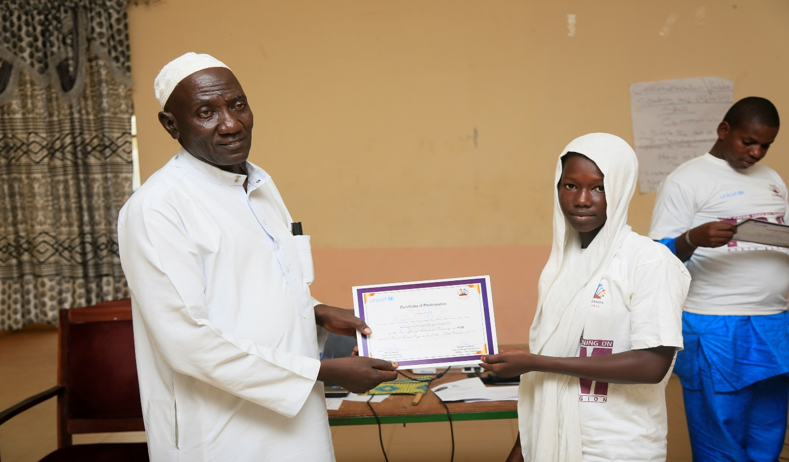
Tida exhorted the students to refer back to Safe Hands for Girls if they needed anything and that Safe Hand is there to support them.
Mr. Dibba spurred the student to share what they have learned with their peers.
The last item on the programme guide was the presentation of the certificates. The students were awarded certificates as a result of their participation.
Mr. Dibba, Mr. Saidykhan and Outass respectively handed the participants their certificates.
Departure.

Requests
- Health booklet on FGM
- Presentations on FGM
- Videos on FGM

Challenges
Fortunately, there were no challenges. The challenges of the school outreach was overcame. All the misconceptions whether religious or health wise was cleared during the training.

Progress and Achievements
- The impact made during the school outreach was measured.
- All the misconceptions were clarified.
- The trainees had an overall understanding on the effects of FGM as well as the laws governing FGM.
- Through the group work/discussion session we were able to evaluate the students understanding of the importance of youth involvement in the Anti-FGM campaign.

Lessons Learnt
- The Anti-FGM laws
- Health complications of FGM
- The religious perspective on FGM
- Community Advocacy

