ANNUAL REPORT
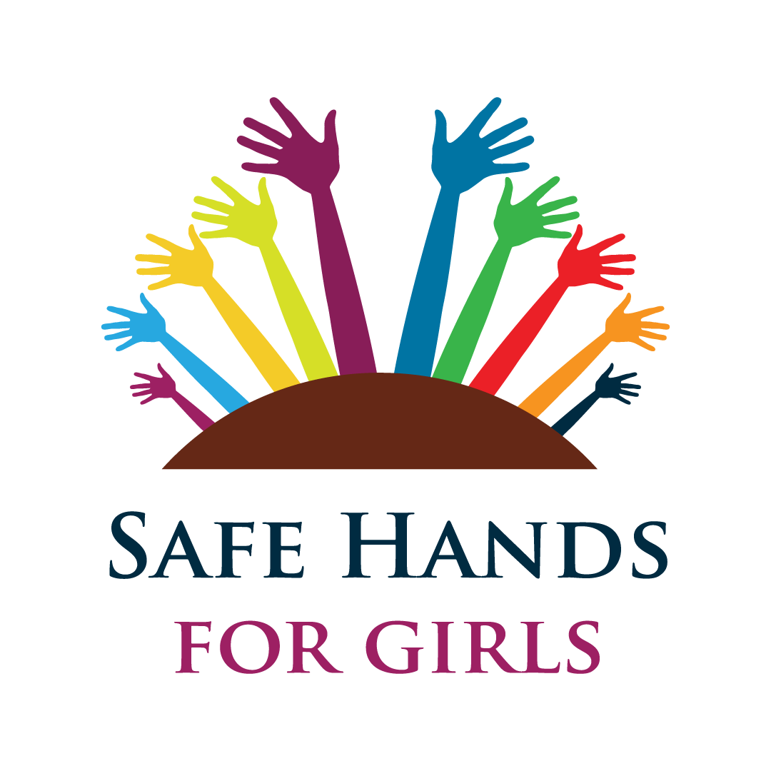

CONTENT
- ACKNOWLEDGEMENT
- INTRODUCTION
- EXECUTIVE SUMMARY
- SUMMARY ACTIVITIES
- CONCLUSION

ACKNOWLEDGEMENT
Our sincerest gratitude is extended to all our donors, partners and sister organizations who contributed their own quarter towards the proper implementation of our projects throughout the year (2017).
Gratitude is also extended to the entire staff of Safe Hands for Girls who have been working tirelessly to see to it that we register success in 2017.
The efforts of staff, donors, partners and others are very well recognized and we look forward to a smoother relationship in 2018.

INTRODUCTION
Safe Hands for Girls is a non- Governmental organization dedicated to helping women and girls that have gone through FGM or are at risk or going through the practice. Safe Hands works towards the fulfillment of the UN convention on the Rights of the child. Being a survivor led project, Safe Hands for Girls understands through lived experience, victims of FGM lose their chance for health, happiness, and fulfillment of their potential hopes in life. Throughout the year, the organization has registered great success in the implementation of its activities all geared towards ending FGM in a generation. This report is meant to highlight the activities has been successfully implemented and has made an impact in the lives of people.

EXECUTIVE SUMMARY
Safe Hands for Girls is a survivor led organization that was founded in 2013 to help end the practice of Female Genital Mutilation, child marriage and other forms of Gender-Based Violence through sensitizations, awareness trainings, workshops, conferences, community outreaches, social media campaigns to name a few. Throughout our work we have made a direct impact on the lives of over………women/girls and even men.

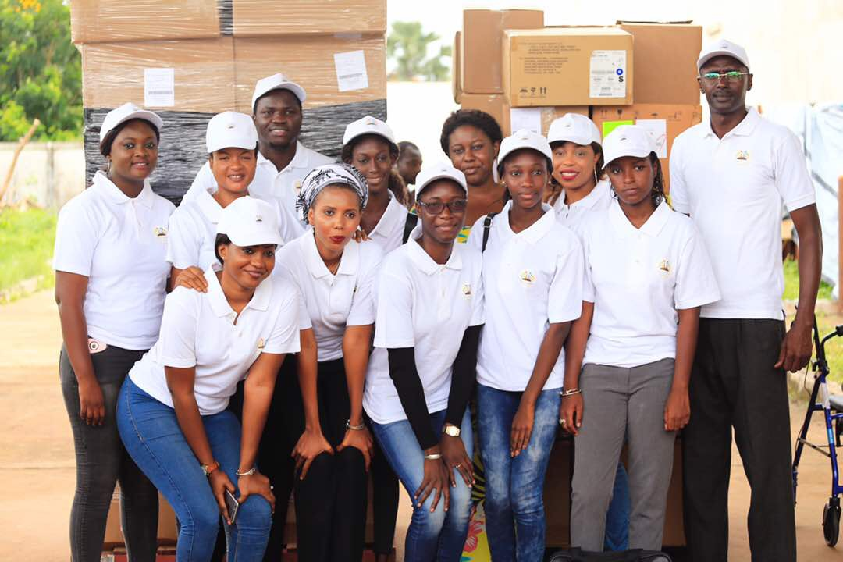

  - ACTIVITY ONE: INTERNATIONAL WOMEN’S DAY, 8th March, 2017.
The international women’s day was funded by Safe Hands for Girls in partnership with the Ebunjan theatre. The activity was celebrated in the form of theatre performance. The idea was coined from the fact that advocacy becomes more effective if issues are visualized for the better understanding of all. The celebration was hosted at the Ebunjan theatre and the Ebunjan theatre troupe dazzled the audience with a poem and play on FGM and Child marriage particularly on the theme “BeBoldForChange”. The celebration was indeed colorful and the audience of over 200 people applauded in satisfaction.

  - ACTIVITY TWO: SCREENING OF JAHA’S PROMISE, 12TH April, 2017.
The screening of Jaha’s promise was held in Dakar precisely at King Fahd Palace. The documentary was centered on the life and struggles of Jaha Dukureh who is the founder of Safe Hands for Girls and a Gambian women’s right activist. The screening targeted people from different parts of the globe, the total crowd was about 200 people both male and female. The storyline served as an inspiration to many individuals on the platform as the feedback from the audience was very much impressive.

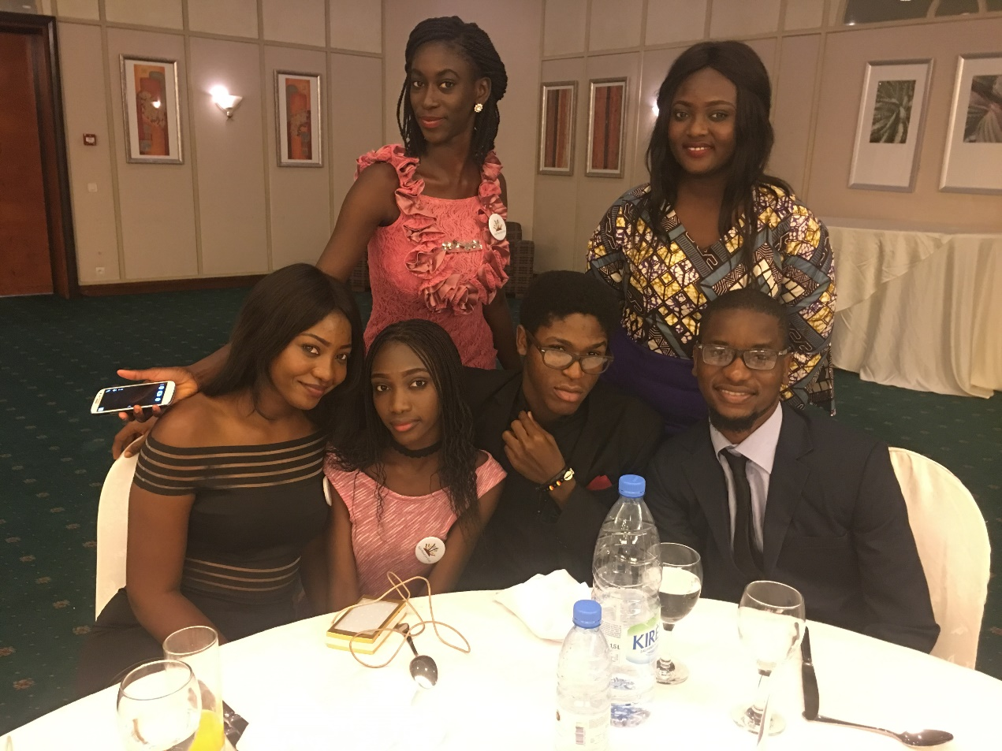

  - ACTIVITY THREE: DAY OF THE AFRICAN CHILD Funded by HDF, 16TH June, 2017.
Safe Hands for Girls through the School Outreach program and the weekly training and mentorship program decided to sit with some members of the school peer health groups to design an activity for the Day of the African child in other to encourage participation from the children and also get them to take ownership of the said activity. The Safe Hands for Girls team as well as Ten (10) schools from the Greater Banjul area were ably represented by students from SOS High School, Gambia Methodist Academy, St. Theresa’s, Muslim Senior Secondary School, Gambia Senior Secondary School, Daddy Jobe Comprehensive, Kotu Senior Secondary School, and 22nd July Academy were present and aiding in the mobilization and organization of the children and other incidentals for the commemoration. Amongst the notable persons present include, Director of the National Youth Council - Lamin Darboe, Director of Social Welfare – Fanta Bai Secka, President of the Female Lawyers Association Gambia - Haddy Dandeh Jabbie, and the Executive Director of Safe Hands for Girls – Jaha Dukureh.

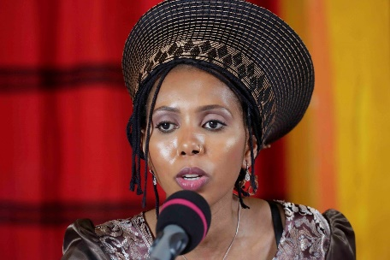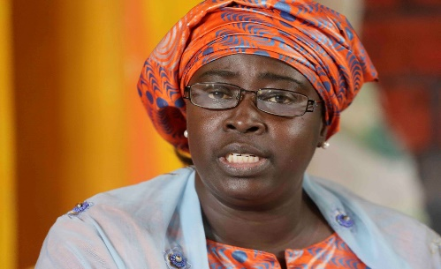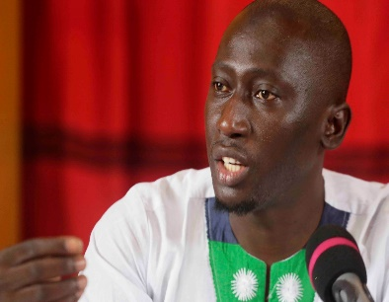

The students also hosted radio talk shows on 5 major National radio stations, each panel comprising of 3 students from the 3 schools who went through the mentorship program and two activist to discuss on FGM and how they are involved in the fight. Topics were chosen for each show for discussion and an expert was invited to also talk on the topic.
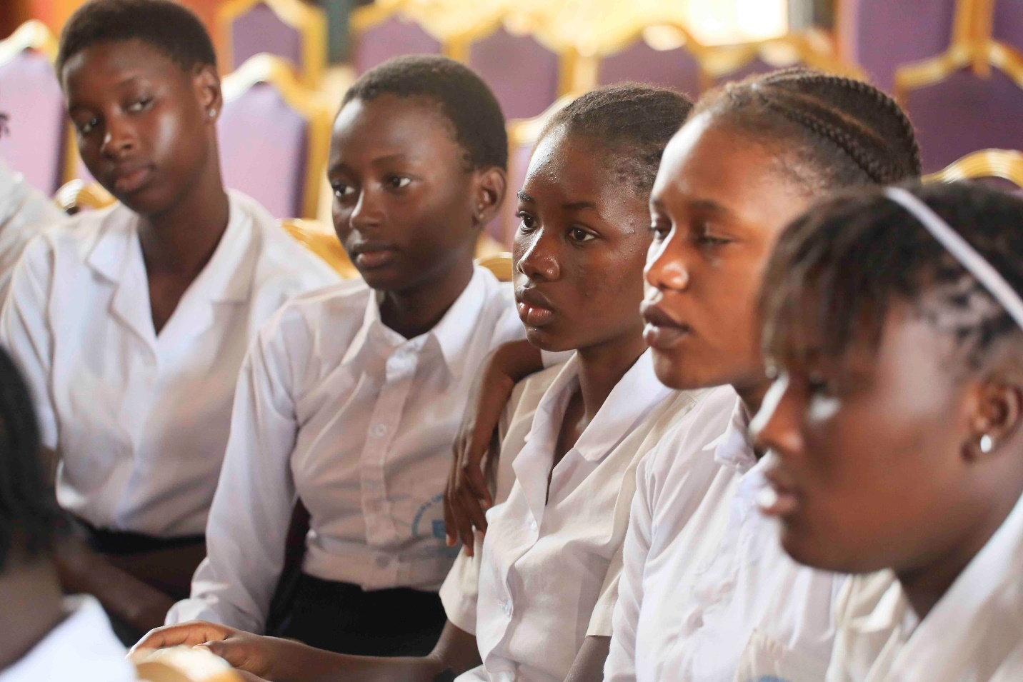

An FGM & Child Marriage drama was performed by students on the day of the commemoration as well as an intergenerational dialogue on issues of FGM and child marriage.

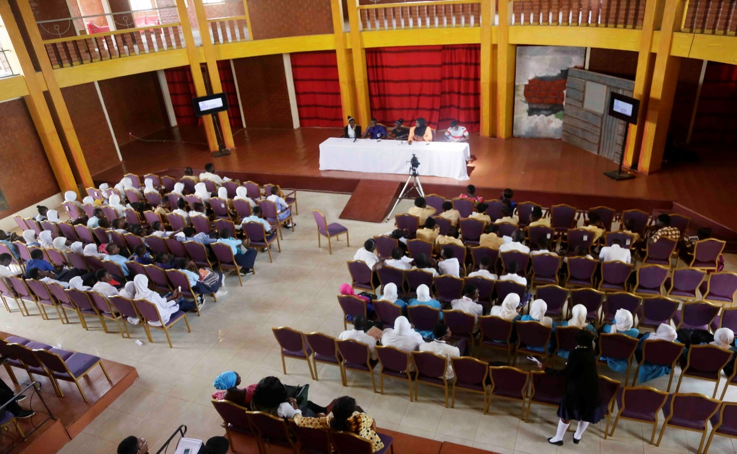

This said activity was replicated throughout the regions in The Gambia.
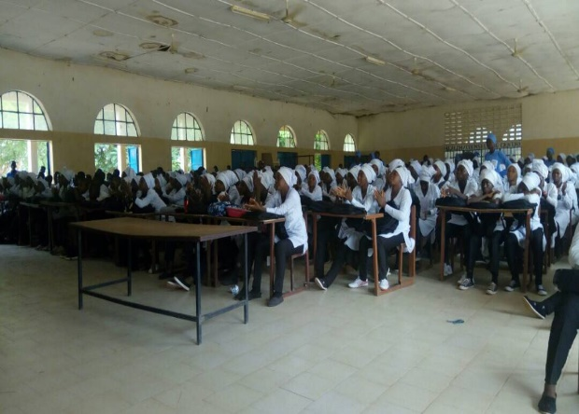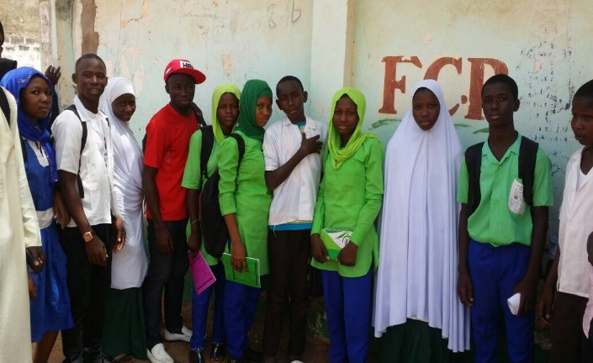

1.4 ACTIVIVITY FOUR: FGM MEDIA AWARDS FUNDED BY HDF, 7TH July, 2017.

There has been clear progress and results in the fight against FGM using media in The Gambia, even though the overall goal is far from achieved the progress is visible through people’s understanding of the subject. The media award ceremony served as a mechanism to recognize significant efforts that 1has been made by individuals and institutions in advancing social change through their various capacities. The award was meant to celebrate national and individual efforts towards the fight against this age-old tradition and encourage others in the process. The awards were presented to journalists and media houses that have been reporting on FGM. Up to 15 categories were awarded and some journalists were recognized by certificates. Some items were given out to outstanding journalist to support the work they are doing, like internet dongles, laptops and pens. There was also a special prize for the overall National winner who received a tuition fee of 1 year journalism course with the Gambia Press Union. The media award hosted 150 guests ranging from activist, government representatives, NGOs media houses and above all journalists.

  - ACTIVITY FIVE: GIRLS INDOOR TRAINING,
The girls indoor training is an activity initiated to serve as a follow up to the school outreach program. The main aim of the indoor training is to enable students feel more comfortable discussing issues as well as better enrich them with the facts on FGM and Child Marriage. This will to a large extend prepare them mentally to become advocates in their various communities and schools. The first badge of trainees were about 20 students from two (2) schools in the KSMD area namely: St. Therese’s Upper Basic School and Charles Jow memorial Academy. After the training they were tasked to establish Safe Hands clubs in their respective schools in which St. Therese’s successfully did and they have been doing tremendously well in disseminating information and facts on FGM to their colleagues.
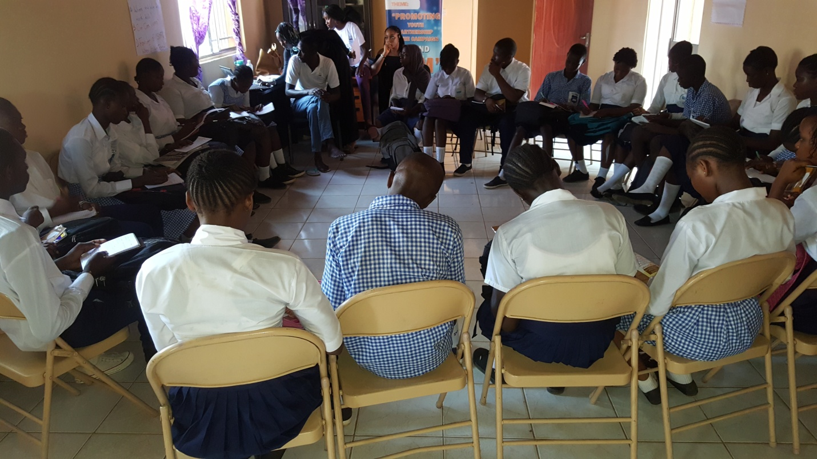

  - ACTIVITY SIX: NORTH BANK SCHOOL OUTREACH, FUNDED BY UNICEF, 11th- 14th July, 2017.

Safe Hands for Girls with support from UNICEF organized a School Outreach on FGM and Advocacy as part of its agenda items to end FGM. The school outreach was meant for students mainly between 12- 19 years of age specifically those in the Upper Basic and Senior Secondary Schools. This we strongly believe will enable them to build their advocacy skills that will help contribute in the Anti-FGM Campaign. The entire training was a success ranging from the approach taken to the end result of the outreach. A total of over 2000 students from 12 different schools were amicably sensitized on the health complications of FGM, religion’s perspective on FGM and the anti-FGM law. After successfully training students in each school, a pledge is taken to show their utmost commitment in the Anti-FGM campaign.

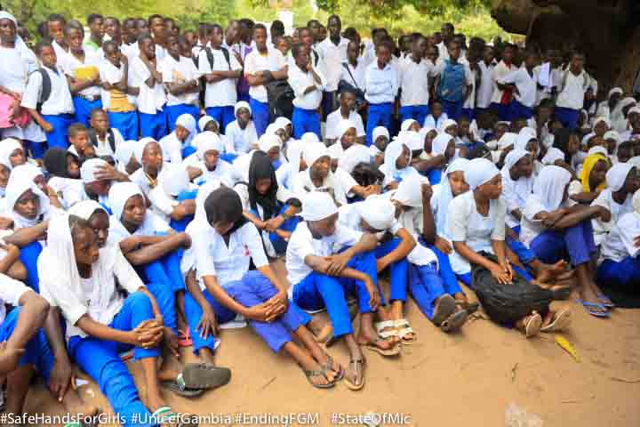

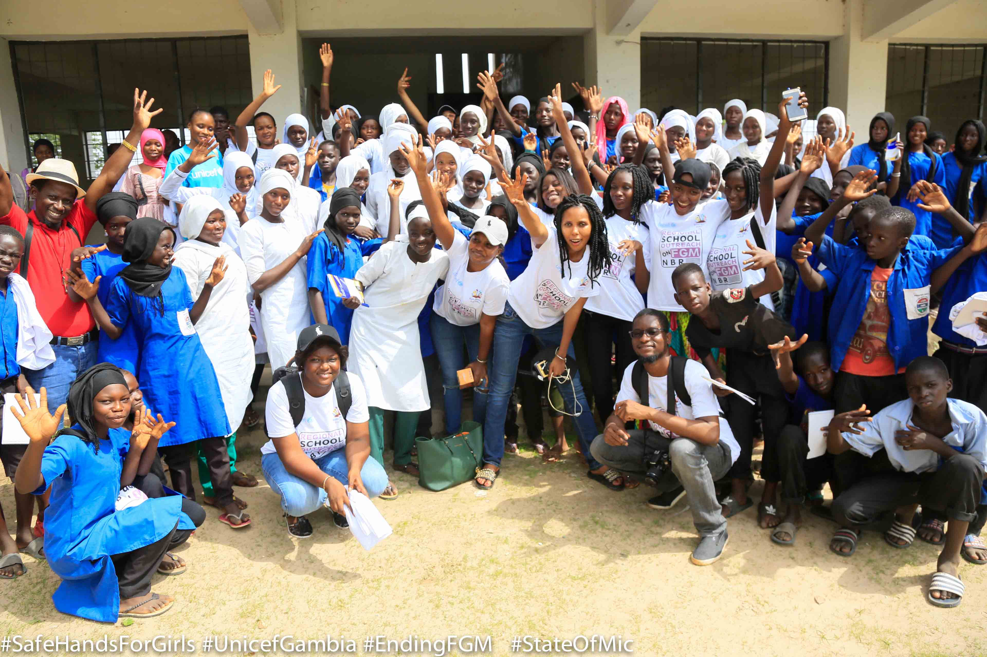

  - ACTIVITY SEVEN: TRAINING OF PROSECUTORS AND CHILD WELFARE OFFICERS in partnership with IHRDA 18th- 19th July, 2017.
The training of prosecutors and child welfare officers gathered over 30 prosecutors and child welfare officers who are the sole enforcers of the FGM and child marriage law in The Gambia to better understand the content of the law as well as other laws outside the jurisdiction of The Gambia. Along with this, they were also trained on the health complications of FGM and child marriage to enable them exercise their duties efficiently without negligence. After the training, a senior prosecutor made a promise that henceforth only the prosecutors and child welfare officers who attended the training will handle cases on FGM and child marriage because as a result of the training they are well aware and already have an understanding of the issue at length.

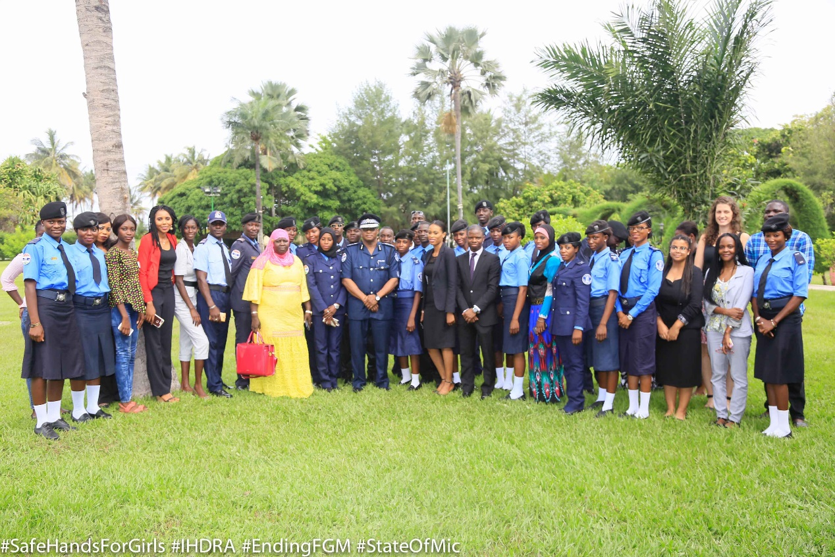

  - ACTIVITY EIGHT: INTRODUCTION TO MONITORING AND EVALUATION BY SATANG NABANEH, 25TH July, 2017.
The main objective of the training was meant to increase the understanding of the Safe Hands staff in designing monitoring and evaluation frameworks. The resource person dealt with the definition of monitoring and evaluation, types of monitoring, key elements of M&E work plan, implementation of monitoring and finally an overview of evaluation. After the training, the resource person asked questions to test the understanding of the staff of which was excellently answered.

  - ACTIVTY NINE: TRAINING ON FINANCIAL MANAGEMENT BY BERNARD GOMEZ, 8TH August, 2017.
The training was also meant to educate the staff on how to properly manage their finances and have a basic understanding of what financial management entails. The resource person dealt with the terms and definitions of financial management, petty cash management, financial management governance, and financial reporting. The training was very interactive as questions were asked during the process of the training and each correct answer was accompanied with a gift. It was indeed a colorful training with information well digested by all staff.

1.10 ACTIVITY TEN: HANDING OVER OF MEDICAL ITEMS TO THE CENTRAL MEDICAL STORE, 23RD August, 2017.
The occasion was graced by the vice president of The Republic of The Gambia, the minister of health and social welfare, director of pharmaceutical services, Executive Director and other staff of Safe Hands. The executive Director, Jaha Dukureh remarked that the handing over of the 40ft container full of medical items is as a result of the love safe Hands has for The Gambia though it is not our area of expertise but we made it a duty to do our best for the entire populace of The Gambia. Part of the items donated included surgical materials, beds, wheel chairs, stitches, examination gulfs, bandages, feeding tubes to name a few. The handing over was one its kind and the minister of health thanked the organization for bringing the items when it was most needed as the health sector was undergoing shortages. The organization finally handed over the items to the minister of health who further handed the items to the Vice president. The vice president was delighted and remarked that ‘building the New Gambia demands commitment through strategic means like the one Safe Hands for Girls has manifested’.
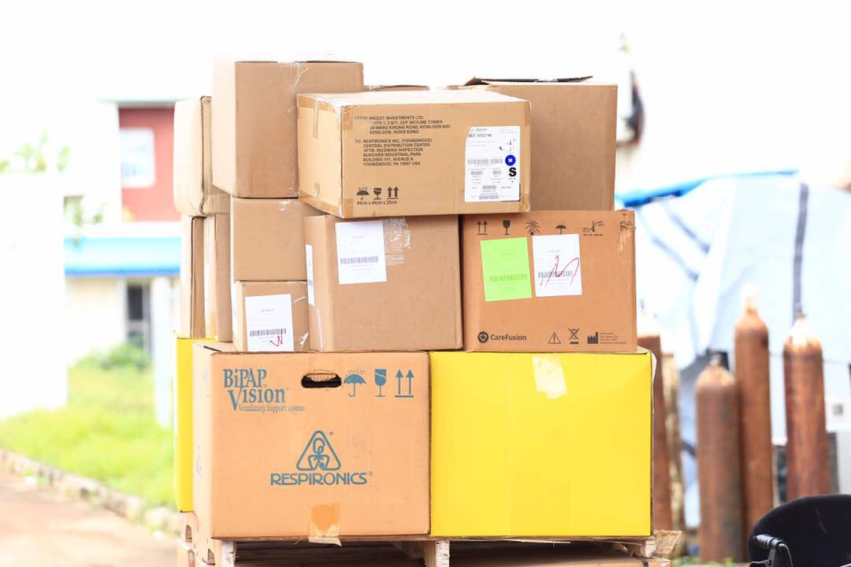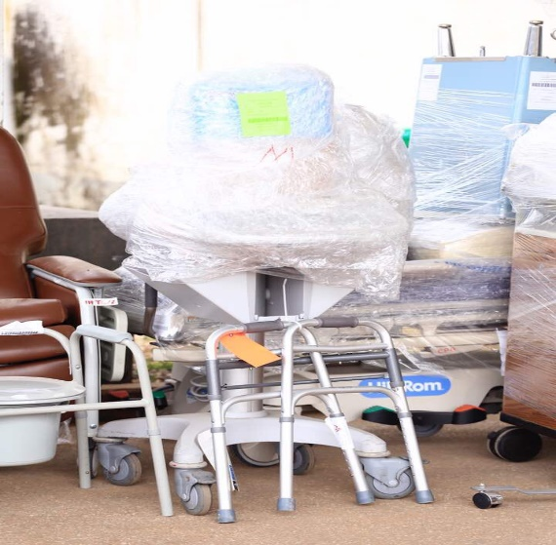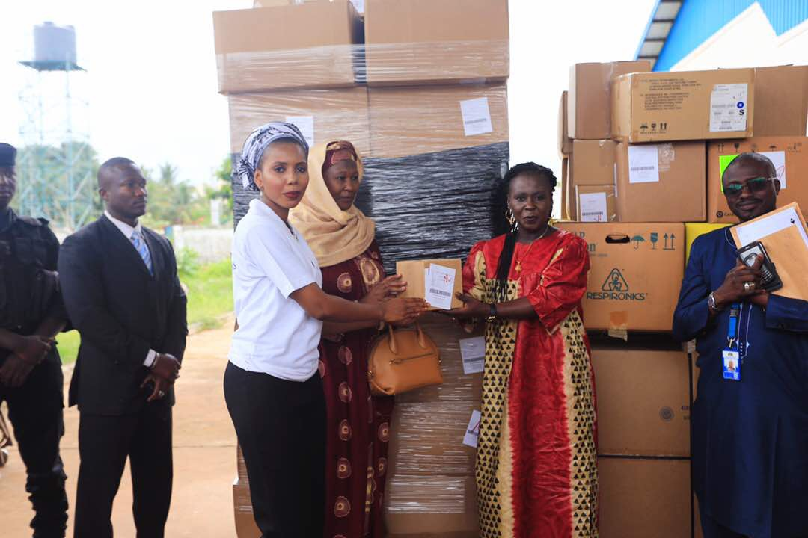

1.1O ACTIVITY ELEVEN: CUTTING SEASON CAMPAIGN FUNDED BY HDF
This campaign was more of intensifying the work on the ground for the holiday season since that is when most of the cutting is done, using the media together with prominent people from the regional governor, the National youth Council rep, main regional mosque Imam, member of parliament, activist, Doctor, a former cutter and media personnel in every region. Under the cutting season campaign different activities were implemented which are as follows:
- RADIO LISTENING GROUPS- Safe Hands for Girls and its partners decided to come up with an activity wherein members of the community will use the media to disseminate information, other women in the same group will listen to them speak and also call to participate, as a result, mobile phones, flash drives and radios were donated to these women groups. Two women kafoos in North Bank Region have already established it and as such Safe Hands paid them a visit to see how effective their work has been.

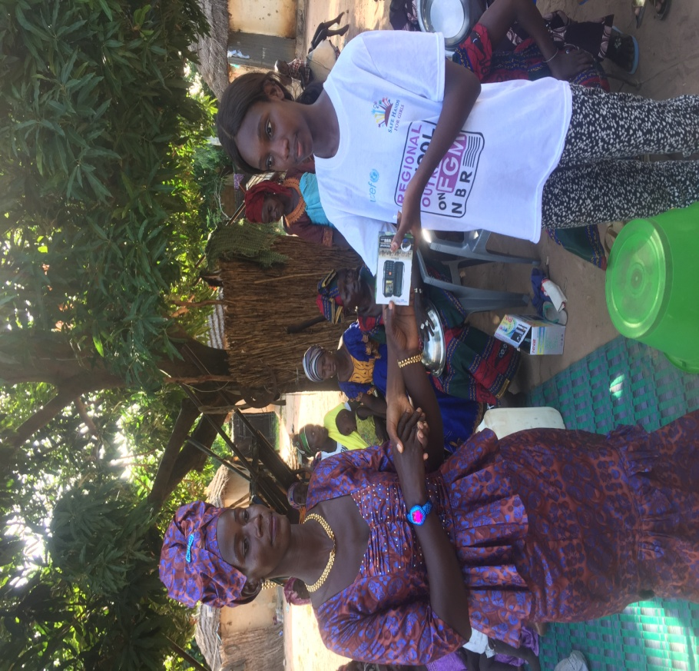
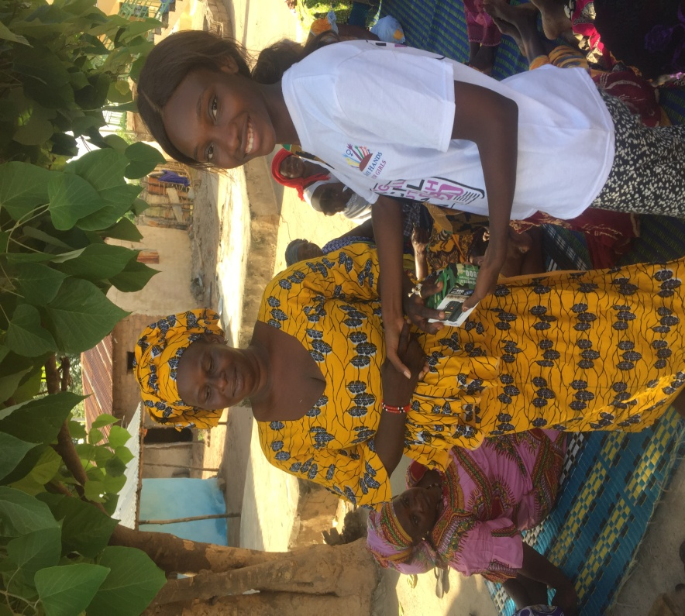

- UNESCO FOOTBALL TOURNAMENT, 22nd –24th September, 2017.
The tournament was organized by National Federation of The Gambia UNESCO Clubs and Centers (NAFGUC), Supported and Funded by Safe Hands for Girls on the theme soccer against FGM. Safe Hands for Girls supported NAFGUC in their activities; Fitness Tournament and radio sensitization as part of its agenda items to end FGM. This was done to raise awareness on the effects of FGM that will help contribute in the Anti-FGM Campaign. A total of over 3000 youth were reached throughout the course of the sensitization.

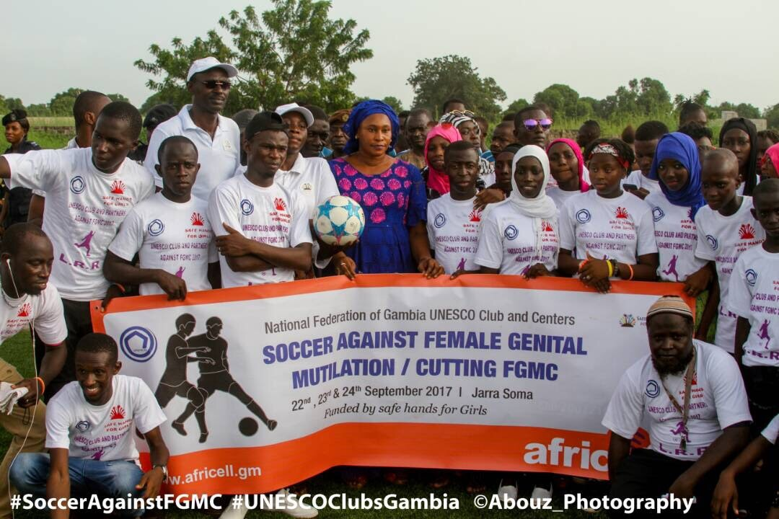

1.12 ACTIVITY TWELVE: PEER GROUP TRAINING FUNDED BY UNICEF, 27th – 29th October 2017.
The training was conducted in the North Bank Region of The Gambia after the completion of the school outreach in the same region. The training was focused on the following areas:
• Health complications of FGM by Mass Laye & Fatoumatta J. Newlands
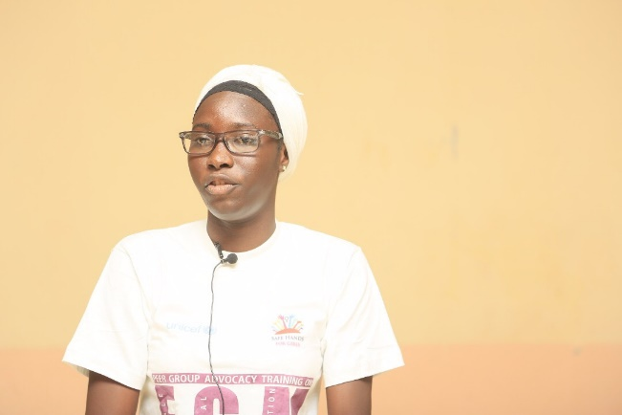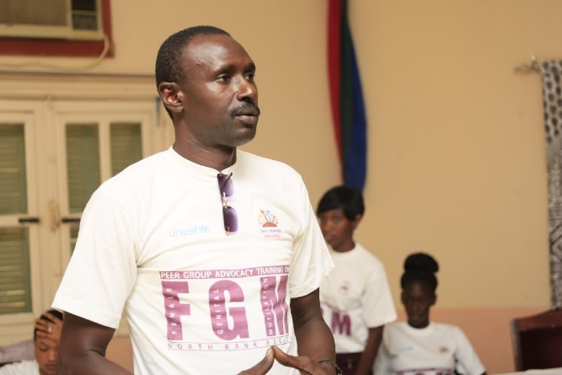
• Anti FGM and Child Marriage laws by Marie Jeng & Awa Gai
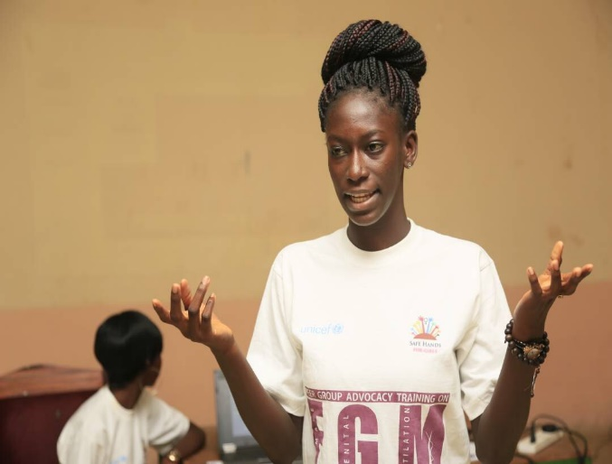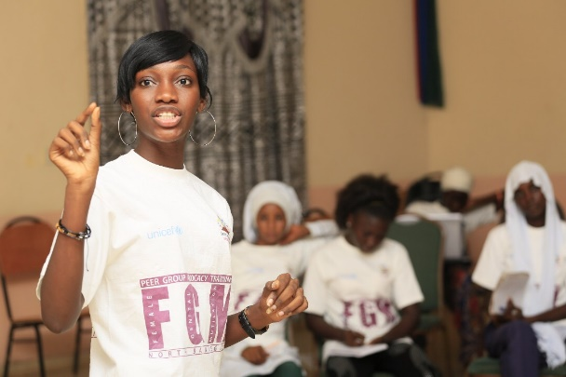
• Importance of youth involvement in the campaign to end both FGM and Child Marriage (GROUP WORK) by participants facilitated by Lisa Camara

• Islam and FGM by Oustass
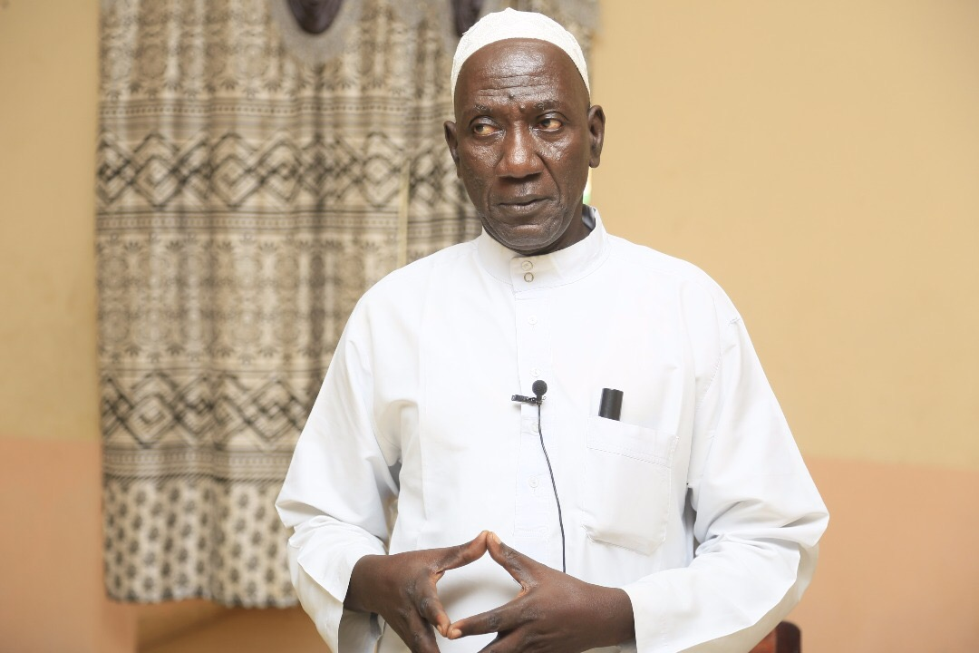

• Communication and public speaking skills by Tida Njie
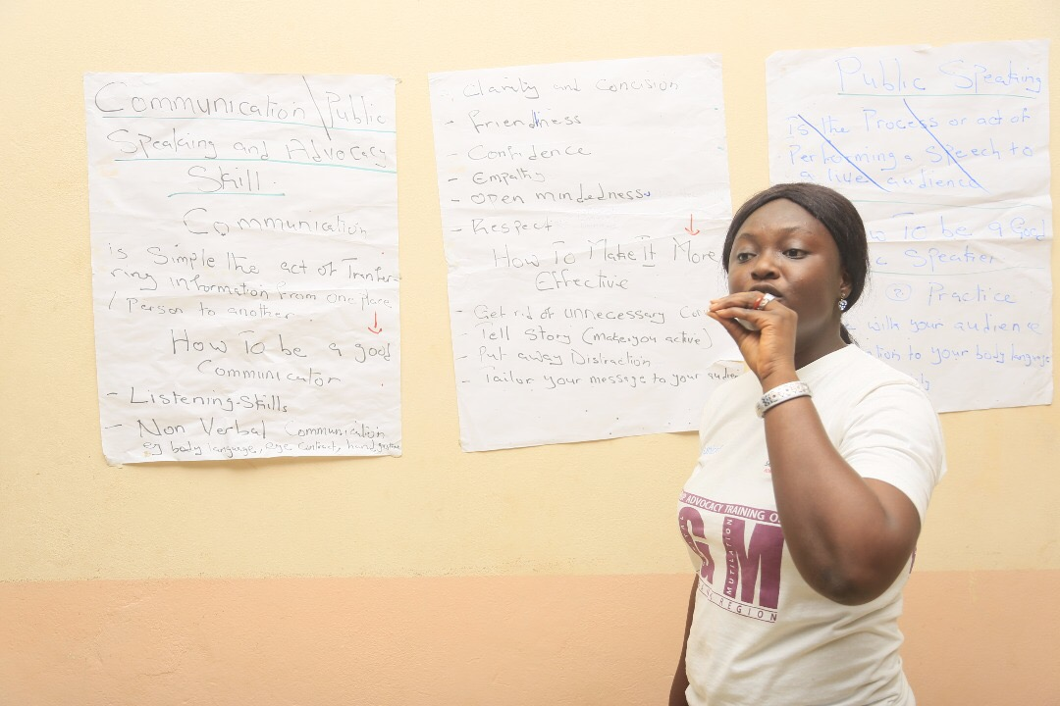
A total of 5 students were selected from each of the 12 schools in the region amounting to 60 students and the selected students were camping with the team throughout the training period. The 5 students from each of the schools will be expected to spearhead the peer health club and ensure its continuous existence as they have the required knowledge and skills as a whole.
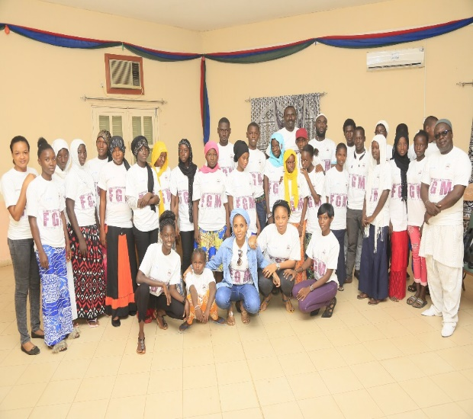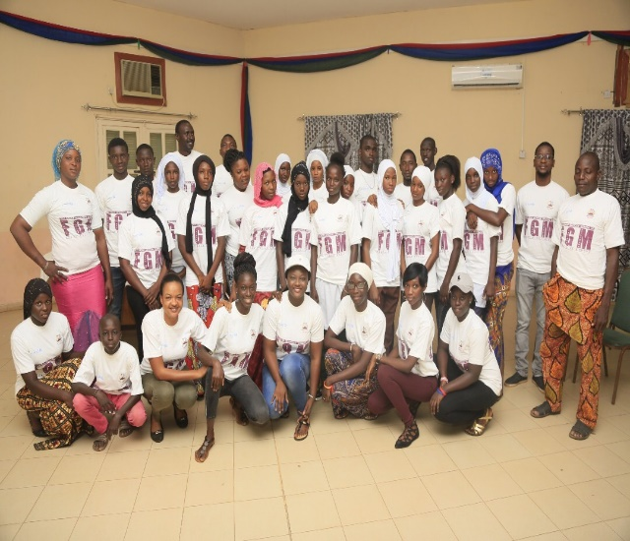

1.13 ACTIVITY THIRTHEEN, GIRL ROSTER TRAINING FUNDED BY POPULATION COUNCIL, 13TH-14TH November, 2017.
Safe Hands for Girls and Population council launched a girls Program in the Gambia starting with rostering training for the team and then the actual rostering to determine the need on the ground, available resources and best approach for each rostered community. The training lasted for two days and the team was efficiently trained on how to use the girl roster tool and the importance of the rostering. The training targeted community based participants from west coast region and upper river region. After the completion of the training the team went on the ground from 15th- 19th November and came up with interesting findings which will be shared during the official launching of the Girl Roster Tool slated for 12th December. This will be accompanied by a workshop meant to design activities for girls based on the findings.

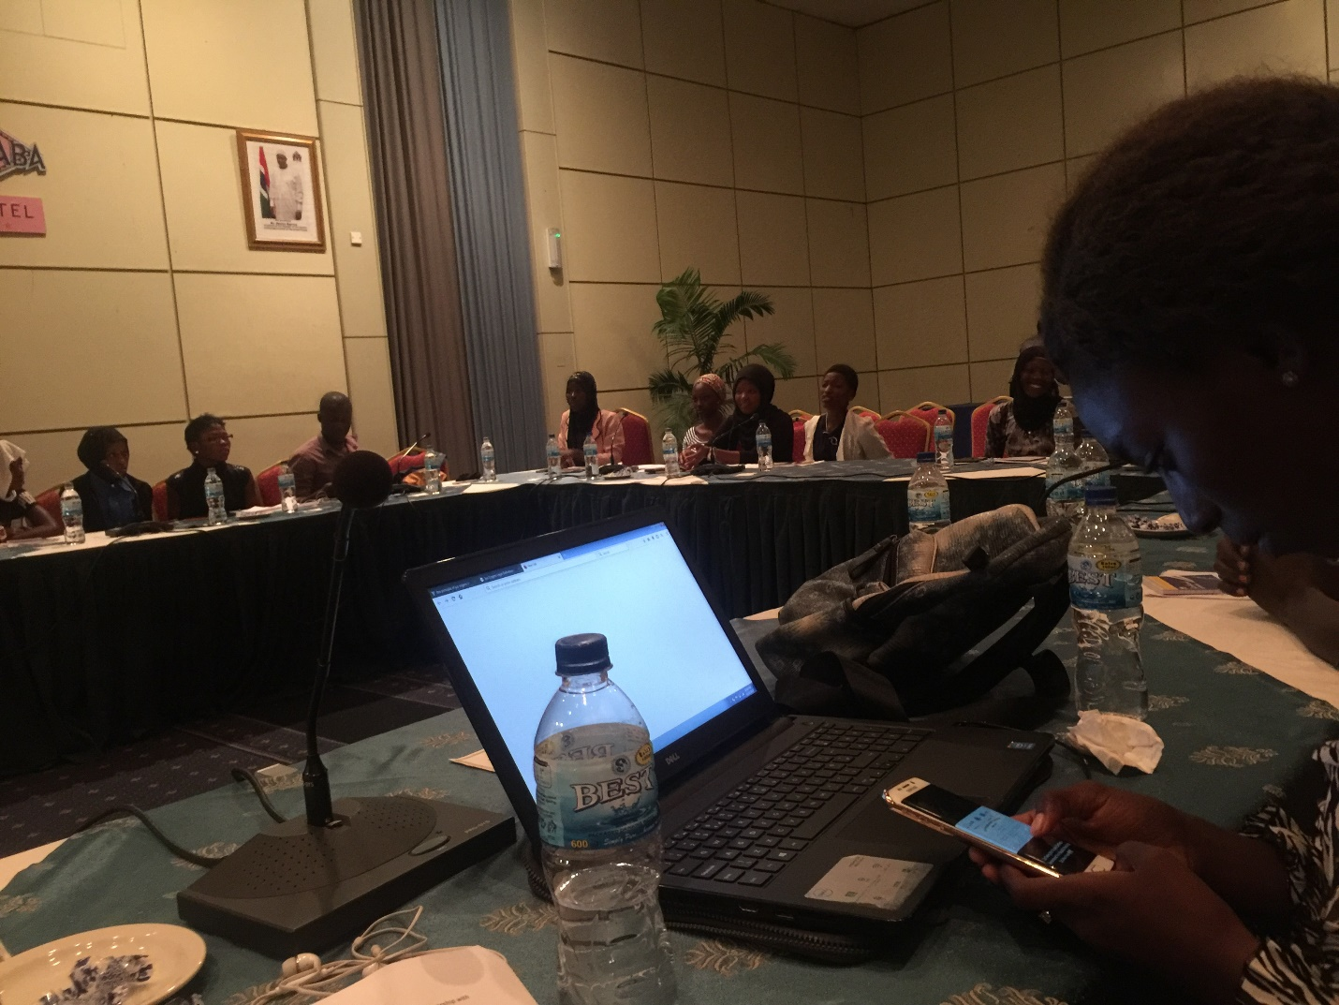

1.14 LAUNCH OF THE BUSINESS PLAN FOR GIRLS FUNDED BY POPULATION COUNCIL AND UNFPA, 12TH- 15TH DECEMBER, 2017.
The launch of the business plan for girls was an activity first of its kind in The Gambia. It gathered a total of over 50 youth from prominent organizations within the length and breadth of The Gambia. Among the training tools include sessions on the shape of girls’ lives as a foundation for the business plan for girls, this session was meant to explore the experience of exclusion among the hardest to reach girls both globally and in The Gambia. Part of the topics also include steps in intentional designs where the population council discussed the approach taken in girl centered programs. The data collected from the rostering conducted in The Gambia was shared and explained in detail to enable organizations take note of what sort of activities to implement and who to target in such implementation. The training was accompanied with a lot of questions, practical, data from The Gambia and outside The Gambia. The end left all participants eager to implement activities and impact the hardest to reach girls in the community.

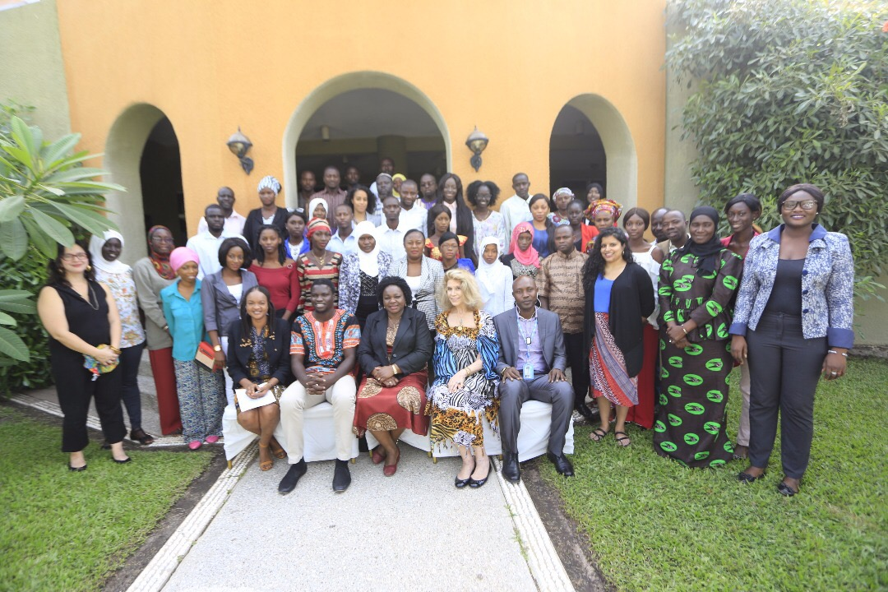

INVITED EVENTS WITHIN THE GAMBIA

- KEY PERSONS INTERVIEW FUNDED BY UNICEF THROUGH NATIONAL YOUTH COUNCIL, 3rd-7th July, 2017.
The law on FGM was passed in 2015, despite the criminalization of this ill-practice, implementation of the law has faced major constraints since the legislation came into effect.
As a result, the National Youth Council tasked Safe Hands for Girls and its partners to conduct series of interviews with key personnel’s in the Gambian Legal system, Government Administration, CSO’s and NGO’s on bottlenecks of the FGM/C law implementation and possible solutions to these bottlenecks. The survey was conducted through a series of interviews, 20 people were selected based on the roles they play in the fight against FGM & how their opinions could prove valuable to the proper implementation of the FGM/C Law. Six questions were drafted and used as questionnaires.

- TRAINING OF VILLAGE DEVELOPMENT COMMUNITIES AND VILLAGE SUPPORT GROUP IN CRR, 2ND-7TH OCTOBER, 2017.
The training was organized by the RCH with funding from UNFPA Gambia office geared towards training the communities on FGM, CHILD MARRIAGE, and GENDER BASED VIOLENCE. Mass Laye of Safe Hands ably represented the organization at the training.

- VALIDATION PROGRAM FOR THE NATIONAL COMUNICATION STRATEGIC DOCUMENT ON FGM and GBV 7th – 8th NOV 2017.
This was organized by the Women’s Bureau Funded by UNICEF. It was a two days program organized by the Women’s Bureau (WB) to validate the National Communication Strategy plan 2017 – 2021 the next four years on FGM & GBV by all the stake holders that are working towards the eliminating of FGM and GBV in the Gambia.

- YOUTH CONVERGENCE ORGANIZED AND FUNDED BY THE GIRL GENERATION
This activity was geared towards bringing together youth from different forms of life to a common platform to discuss on how we can contribute towards ending FGM.

- SENSITIZATION OF THE DISTRICT AUTHORITIES ON FGM and EARLY MARRIAGE IN WCR EAST AND LRR WEST
The program was organized by the NGBV with AMPLIFY CHANGE AND ACTION AID INTERNATIONAL. It was geared towards sensitizing the District Authorities and the governing body at District level.

INVITATIONS OUTSIDE THE GAMBIA
- BUSINESS PLAN MEETING FOR GIRLS- The meeting lasted for two days. With each meeting, everyone was informed by the sharing of experience, activities and the overall process to inform their own work by moving forward. It was also meant to discuss on the international design plan for girls to be held in The Gambia in December.
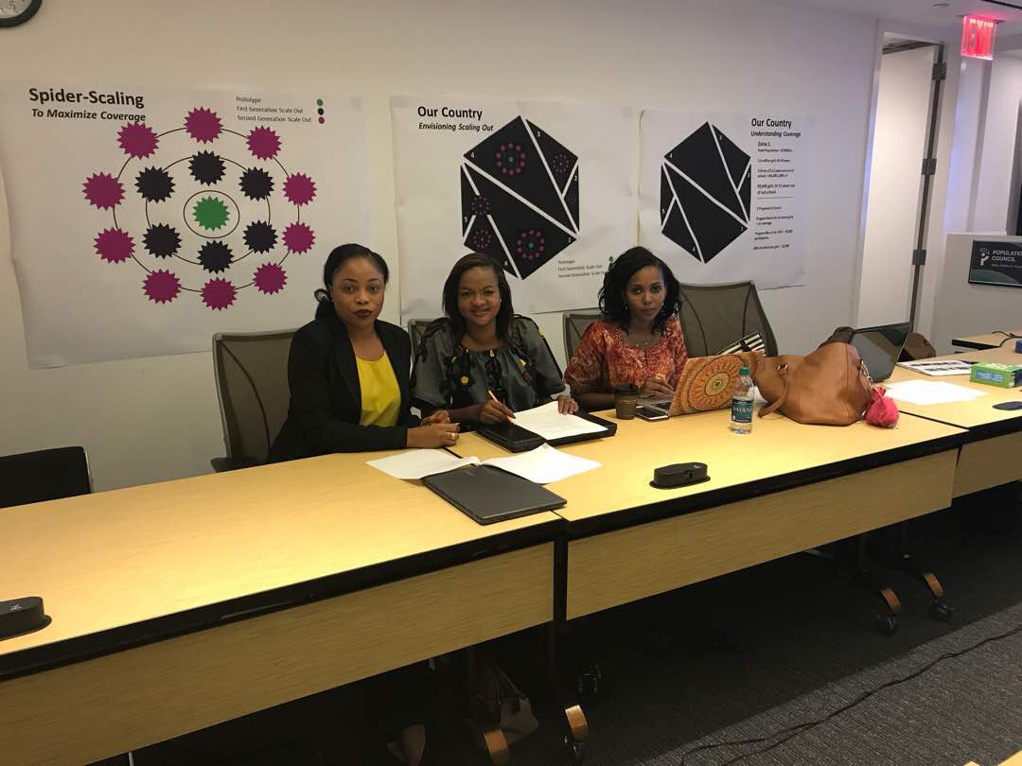

- CONVENING MEETING ON FGM, GUINEA CONAKRY- it was organized by the vital voices global partnership, the convening is a project of voices against violence. It was implemented in partnership with the inter- African Committee on harmful traditional practices. It applies an innovative and interactive approach aimed at creating a holistic and victim centered response to addressing FGM/C in five West African countries including The Gambia. The participants were exposed to multi- disciplinary interactions, series of mini lectures, small group activities and conversations with local experts. Lisa Camara, program Manager ably represented the organization.

